Discussion Paper on possible simplification of data-service linking in INSPIRE

Authors: Michael Lutz (JRC), Robert Tomas (JRC), Joeri Robbrecht (DG ENV), Heidi Vanparys (DK), Marie Lambois (FR), Ine de Visser (NL), Thijs Brentjens (NL)
Version: v0.2
Date of last revision: 2018-08-28

Preface
This paper reflects discussions in the MIG-T on the topic of data-service linking in INSPIRE. These discussions are related to the agreed ad-hoc MIG-T actions on
- preparing a guidance document on how data sets and services are being linked in current ISO metadata and how links are created in the INSPIRE geoportal and
- drafting a proposal to amend the use of the resource locator metadata element in the Metadata IR,
as well as recent discussions in the temporary sub-group 2017.4 on validation and conformity testing. It also integrates elements from the discussion paper "IR on metadata – Change proposal(s) on the 'Resource Locator' element" presented to the 8th MIG meeting.
The current version has been drafted by a small MIG-T ad-hoc group based on a workshop on 1-2 August 2018 in Ispra. It will be presented for further discussion at the MIG-T meeting in October and subsequently to the MIG meeting in November 2018.

Introduction
This discussion paper aims to explore the feasibility of (and options for) simplifying the approach for documenting and using the linkage between data sets and download and view services in INSPIRE.
The paper is motivated mainly by the following issues and assumptions:
- Users of the INSPIRE infrastructure are mainly interested in accessing data; services are just a means to this end. Therefore, the focus should be on data.
- MS are experiencing difficulties to implement the current TG requirements and recommendations, partly because they require extensions to existing standards that are not (widely) supported by existing software products.
- During the development of the Thematic Viewer, it has been difficult to establish working links for downloading and viewing data sets for all MS, e.g. because
  - the requirements currently prescribed in the TGs for documenting these links are difficult to implement and understand and therefore not widely (correctly) implemented by MS;
  - some information (e.g. restrictions on public access) is documented for both data and services; and
  - there is some duplication between the metadata required for services in the Metadata and the Network Services IRs.
- The MIG and its sub-groups (mainly 2017.4) are experiencing difficulties in drafting clear and unambiguous requirements and tests in the TGs.
Therefore, a simplified approach for data-service linking should ideally
- be centred on data (rather than treating data and services as equally important resources)
- not require extensions to existing standards
- limit the implementation options
- remove duplicate or unnecessary elements in metadata descriptions (mainly for services)
In the remainder of the paper, we will outline a proposal for such a simplified approach, a number of open (technical) issues for further discussions, as well as possible scenarios on how the approach could be implemented (if endorsed) in the INSPIRE legal and technical framework and by the data and service providers in the MS.

A simplified approach for data-service linking
The proposed approach aims at supporting the following user stories:
- As a user, I want to be able to search relevant data sets using a discovery service (via a geoportal) based on at least the search criteria defined in Art. 11(2) of the Directive.
- As a user, once I have discovered a data set in the discovery service, I want to be able to find in the metadata sufficient information to directly access the service metadata of the download/view service(s) that provide access to the selected/discovered data.
- As a user, once I have discovered a data set in the discovery service, I want to be able to find in the metadata sufficient information to directly download/view the selected/discovered data.
The approach aims at implementing these requirements in the simplest possible way.

Conceptual model
To illustrate the approach, we focus on the relationships between data sets, network services and (identifiable) representations of data that are provided by these services (e.g. spatial object types for WFS-based download services or layers for WM(T)S-based view services) shown in the conceptual model in Figure 1.
NOTE The relationship between spatial object types or layers and the data sets they represent can be inferred in some cases from the other relationships. However, this depends on the implementation approach chosen by data / service providers. Particularly when a service provides access to more than one data set, the relationship between spatial object type / layer and data set may not always be clear.
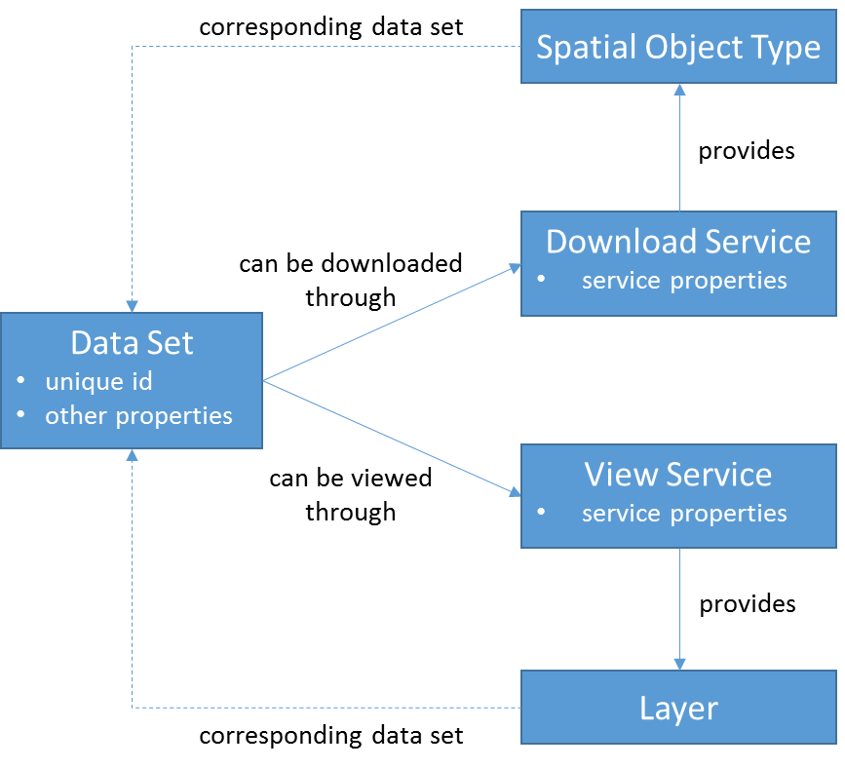
Figure 1. Conceptual model – relationships between data sets, network services and spatial object types / layers

Overview
The approach is based on the following basic principles:
- Data sets are largely documented in metadata as currently proposed in the TGs, with some modifications for documenting data-service linkage – see (3) (Figure 2).
- Download and view services are no longer documented in stand-alone (ISO 19119) service metadata records, but exclusively through the metadata returned by the service itself as a response to a Get Download/View Service Metadata request (Figure 3).
- The metadata returned by a network service only includes metadata elements that do not duplicate data set metadata and are useful to users; all other metadata elements defined in the Metadata IRs for services do not have to be provided (unless of course they are required by the relevant base standard).
- In the metadata for each data set, resource locator elements are provided for at least one view and one download service, pointing to a Get Download/View Service Metadata request.
- Optionally, where a view/download service provides access to more than one data set and to facilitate the development of client applications, additional resource locator elements can be provided, pointing directly to a Get Map or Get Spatial Data Set request.

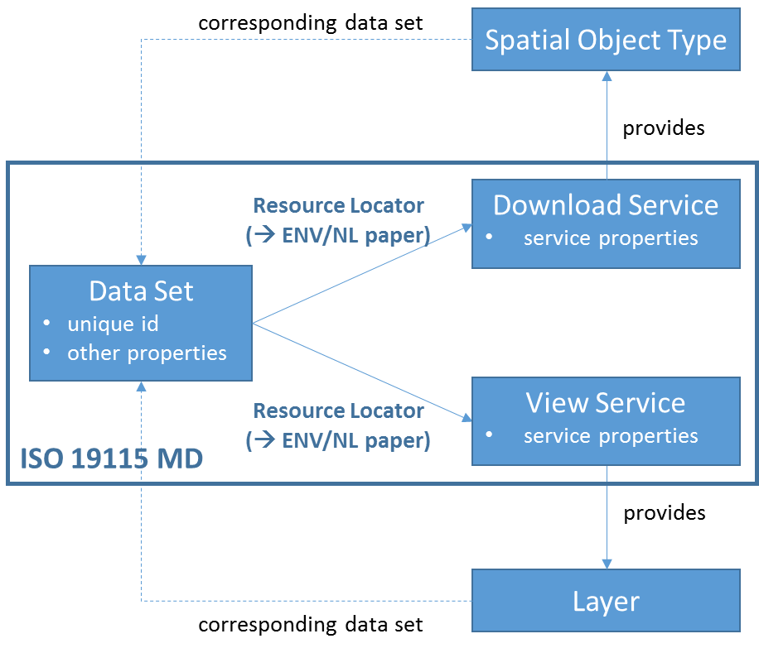
Figure 2. Data set metadata
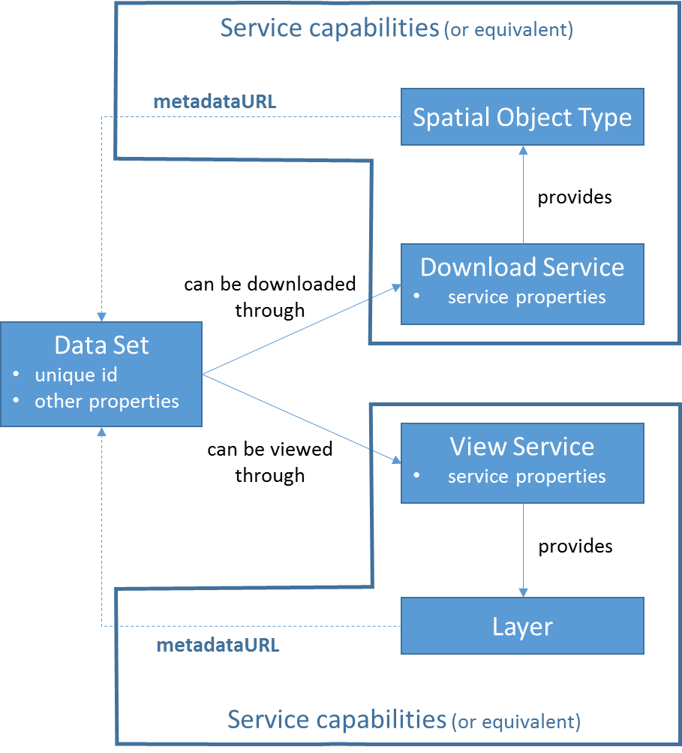
Figure 3. Service metadata

Detailed requirements and recommendations
The following detailed requirements and recommendations define the proposed approach in more detail.
- The following requirement should be modified for data set metadata from currently (Metadata TG v2.0.1):
TG Requirement 1.8: metadata/2.0/req/datasets-and-series/resource-locator
A resource locator linking to the service(s) providing online access to the described data set or data set series shall be given, if such online access is available.
If no online access for the data set or data set series is available, but there is a publicly available online resource providing additional information about the described data set or data set series, the URL pointing to this resource shall be given instead.
These links shall be encoded using gmd:transferOptions/gmd:MD_DigitalTransferOptions/gmd:onLine/gmd:CI_OnlineResource/gmd: linkage/gmd:URL element.
The multiplicity of this element is0..n.

to (new proposal):
TG Requirement 1.8: metadata/2.0/req/datasets-and-series/resource-locator
One or more resource locators linking to the view service(s) providing online access to the described data set or data set series shall be given.
One or more resource locators linking to the download service(s) providing online access to the described data set or data set series shall be given.
These links shall be encoded using gmd:transferOptions/gmd:MD_DigitalTransferOptions/gmd:onLine/gmd:CI_OnlineResource/gmd: linkage/gmd:URL element.
The multiplicity of this element is 2..n.
The URLs provided as the value of the gmd:transferOptions/gmd:MD_DigitalTransferOptions/gmd:onLine/gmd:CI_OnlineResource/gmd: linkage/gmd:URL element shall point to the response of a Get View/Download Service Metadata request of the service providing access to this data set.
The gmd:CI_OnlineResource element containing the given gmd:linkage element shall contain a gmd:protocol/gmx:Anchor element pointing to one of the values of the Protocol code list.
The gmd:CI_OnlineResource element containing the given gmd:linkage element shall contain a gmd:applicationProfile/gmx:Anchor element pointing to one of the values of the ApplicationProfile code list.
and:
TG Recommendation 1.x: metadata/2.0/rec/datasets-and-series/resource-locator-direct-access
If there is a publicly available online resource providing additional information about the described data set or data set series, the URL pointing to this resource shall be given as well, again encoded using the gmd:transferOptions/gmd:MD_DigitalTransferOptions/gmd:onLine/gmd:CI_OnlineResource/gmd: linkage/gmd:URL element.

Open issue: In the application profile element, do we need to distinguish "pre-defined" and "direct access" download services?

- The following recommendations should be added for data set metadata:
TG Recommendation 1.x: metadata/2.0/rec/datasets-and-series/resource-locator-direct-access
For cases, where a network service provides more than one data set, a resource locator should be given that also contains a link for the direct access for downloading or viewing the described data set.
The resource locator elements should be encoded as specified in Requirement 1.8.

- A general recommendation should be added for cases, where a network service provides download or view access to several data sets, without physically aggregating the individual data sets (e.g. a regional/national service providing access to several local/regional data sets). In these cases, the "virtual data set" to which the service provides access should also be described with metadata including the links to the network services. The relationship to the component data sets that make up this "virtual data set" should be described textually in the lineage element.
Open issues: How will this be evaluated when calculating monitoring indicators? Do we need additional recommendations (as an offer) for more formal/structured description of aggregation, e.g. using LI_Lineage/LI_Source (aggregate → component data sets) or MD_Identification/MD_AggregateInformation (component → aggregate data set)?

- The requirements for metadata for network services should be modified to refer only to the metadata returned by the service itself as a response to a Get Download/View Service Metadata request. The metadata elements to be provided should be simplified as specified in the "Proposed simplification" column in the table below. The "Comment / Justification" column explains the rationale for the proposal, and the Atom, WFS and WMS columns indicate whether a mapping to a standard field has been defined for this metadata element in the relevant TGs.
NOTE The simplification proposed in the table only refers to the INSPIRE requirements. Where the base standard (e.g. WMS, WFS) requires additional metadata elements, these have to be provided as well (to be compliant with the base standard).

Section / article | Element name | INSPIRE multiplicity | INSPIRE obligation | Proposed simplification | Comment / Justification | Atom | WFS | WMS
Part B 1.1 | Resource title | 1 | Mandatory | Keep | This may be useful for aggregated services and for displaying in the user interface | ✓ | ✓ | ✓
Part B 1.2 | Resource abstract | 1 | Mandatory | Remove | The abstract of the service is often not useful and seldom used
Part B 1.3 | Resource type | 1 | Mandatory | Remove | If service metadata is available only through the given service, the type is implicit
Part B 1.4 | Resource locator | 0..* | Conditional, mandatory if linkage to service is available | Remove | If service metadata is available only through the given service, the resource locator is implicit; furthermore, more detailed information is available in the operations metadata of the service
Part B 1.6 | Coupled resource | 0..* | Conditional, mandatory if linkage to data sets on which the service operates are available. | Turn into a recommendation | This is not strictly necessary, but might be useful, especially for aggregated services providing access to more than one data set | ✓ | ✓ | ✓
Part B 2.2 | Spatial data service type | 1 | Mandatory | Keep, but implement in data set metadata | This is implemented by providing the application profile element on the data set's resource locator | – | – | –
Part B 3 | Keyword | 1..* | Mandatory | Remove | Service keywords (if they are at all necessary) can be covered by data set keywords or the name or description elements of the resource locator
Part B 4.1 | Geographic bounding box | 0..* | Conditional, mandatory for services with an explicit geographic extent. | Remove | This is covered by the bounding box of the data set (or virtual data set)
Part B 5 | Temporal reference |  | At least one of Temporal extent, Date of publication, Date of last revision or Date of creation must be given | Remove | This is covered by the temporal reference of the data set
Part B 6.2 | Spatial resolution | 0..* | Mandatory when there is a restriction on the spatial resolution for this service | Remove | This is covered by the spatial resolution of the data set. Service-specific restrictions could be expressed through conditions on access and use
Part B 7 | Conformity | 1..* | Mandatory | Remove | This is mainly relevant for Spatial Data Services that are not network services; using a value from the INSPIRE code list for the application profile of the resource locator could be interpreted as having an INSPIRE-compliant network service.
Part B 8.1 | Conditions applying to access and use | 1..* | Special values for unknown conditions or no applying conditions may be used | Keep, but implement in data set metadata | Conditions specific to the access to the data set through a specific service can be expressed in the data set metadata.  This would also help users to decide already when looking at the data set metadata whether the data set is useful for their purposes or not.  Note that this requires good coordination in cases where different (departments inside) organisations are responsible for data and service provision. | – | ✓ | ✓
Part B 8.2 | Limitations on public access | 1..* | Special value for no limitations may be used | Keep, but implement in data set metadata | Limitations specific to the access to the data set through a specific service can be expressed in the data set metadata.  This would also help users to decide already when looking at the data set metadata whether the data set is useful for their purposes or not.  Note that this requires good coordination in cases where different (departments inside) organisations are responsible for data and service provision. | ✓ | ✓ | ✓
Part B 9 | Responsible organisation | 1..* | Mandatory | Keep | This may be different from the organisation responsible for the data set. | ✓ | ✓ | ✓
Part B 10.1 | Metadata point of contact | 1..* | Mandatory | Remove | No longer relevant if service metadata are no longer used.
Part B 10.2 | Metadata date | 1 | Mandatory | Remove | The date of last update of the service would be more relevant.
Part B 10.3 | Metadata language | 1 | Mandatory | Remove | Automatic translation tools can nowadays figure out the language used in a document.  Open issue: More guidance (and probably simplification) is needed for the usage of languages in network services.

These following code snippet illustrates these requirements using examples of ISO 19115/19139 metadata for data sets and service capabilities / Atom feed elements for services.

<gmd:MD_Metadata ...>
<gmd:contact ...>
<!-- Responsable party for the spatial data set -->
<gmd:CI_ResponsibleParty> ...
<gmd:role>
<gmd:CI_RoleCode codeList="http://standards.iso.org/ittf/PubliclyAvailableStandards/ISO_19139_Schemas/resources/Codelist/ML_gmxCodelists.xml#CI_RoleCode"
codeListValue="pointOfContact"/>
</gmd:role>
</gmd:CI_ResponsibleParty>
...
<!-- Data Identification incl. use constraints and limitations -->
<gmd:identificationInfo ...>
<gmd:MD_DataIdentification>
...
<!-- Conditions applying to access and use -->
<gmd:resourceConstraints>
<gmd:MD_Constraints>
<!-- on the spatial data set -->
<gmd:useLimitation>
<gco:CharacterString> ... </gco:CharacterString>
</gmd:useLimitation>
<!-- on the spatial data service -->
<gmd:useLimitation>
<gco:CharacterString> ... </gco:CharacterString>
</gmd:useLimitation>
...
</gmd:MD_Constraints>
</gmd:resourceConstraints>
<!-- Limitations on public access -->
<gmd:resourceConstraints>
<gmd:MD_LegalConstraints>
<!-- on the spatial data set -->
<gmd:useLimitation>
<gco:CharacterString> ... </gco:CharacterString>
</gmd:useLimitation>
<!-- on the spatial data service -->
<gmd:useLimitation>
<gco:CharacterString> ... </gco:CharacterString>
</gmd:useLimitation>
...
<gmd:accessConstraints> ... </gmd:accessConstraints>
...
<gmd:otherConstraints> ... </gmd:otherConstraints>
</gmd:MD_LegalConstraints>
</gmd:resourceConstraints>
...
</gmd:MD_DataIdentification>
</gmd:identificationInfo>
<!-- Distribution info -->
<gmd:distributionInfo ... >
<gmd:MD_Distribution>
...
<!-- Responsable party for distributing the spatial data set e.g. through network services -->
<gmd:distributor xlink:type="simple">
<gmd:MD_Distributor>
<gmd:distributorContact xlink:type="simple">
<gmd:CI_ResponsibleParty>
...
<gmd:role>
<gmd:CI_RoleCode codeList="http://standards.iso.org/ittf/PubliclyAvailableStandards/ISO_19139_Schemas/resources/Codelist/ML_gmxCodelists.xml#CI_RoleCode"
codeListValue="distributor"/>
</gmd:role>
</gmd:CI_ResponsibleParty>
...
</gmd:distributorContact>
</gmd:MD_Distributor>
</gmd:distributor>
<!-- Transfer options - description of the spatial data view service -->
<gmd:transferOptions>
<gmd:MD_DigitalTransferOptions>
...
<!-- Generic service endpoint -->
<gmd:onLine>
<gmd:CI_OnlineResource>
<gmd:linkage>
<gmd:URL>https://xxx.xxx.xxx/wms?</gmd:URL>
</gmd:linkage>
<gmd:protocol>
<gmx:Anchor xlink:href="http://inspire.ec.europa.eu/metadata-codelist/ProtocolValue/OGC:WMS-1.3.0">OGC:WMS-1.3.0</gmx:Anchor>
</gmd:protocol>
<gmd:applicationProfile>
<gmx:Anchor xlink:href="http://inspire.ec.europa.eu/metadata-codelist/ApplicationProfile/view">INSPIRE View Network Service</gmx:Anchor>
</gmd:applicationProfile>
<gmd:name>
<gco:CharacterString> xxx </gco:CharacterString>
</gmd:name>
<gmd:description>
<gco:CharacterString> xxx </gco:CharacterString>
</gmd:description>
</gmd:CI_OnlineResource>
</gmd:onLine>
<!-- Optionally you could also describe the service interface in more detail e.g. for the getcapabilities() -->
<gmd:onLine>
<gmd:CI_OnlineResource>
<gmd:linkage>
<gmd:URL>https://xxx.xxx.xxx/wms?request=GetCapabilities&amp;version=1.3.0&amp;service=wms</gmd:URL>
</gmd:linkage>
<gmd:protocol>
<gmx:Anchor xlink:href="http://inspire.ec.europa.eu/metadata-codelist/ProtocolValue/OGC:WMS-1.3.0-http-get-capabilities">OGC:WMS-1.3.0-http-get-capabilities</gmx:Anchor>
</gmd:protocol>
<gmd:applicationProfile>
<gmx:Anchor xlink:href="http://inspire.ec.europa.eu/metadata-codelist/ApplicationProfile/view">INSPIRE View Network Service</gmx:Anchor>
</gmd:applicationProfile>
<gmd:name>
<gco:CharacterString>xxx</gco:CharacterString>
</gmd:name>
<gmd:description>
<gco:CharacterString>xxx</gco:CharacterString>
</gmd:description>
</gmd:CI_OnlineResource>
</gmd:onLine>
...
</gmd:MD_DigitalTransferOptions>
</gmd:transferOptions>
<!-- Transfer options - description of the spatial data download service for direct access download-->
<gmd:transferOptions>
<gmd:MD_DigitalTransferOptions>
...
<!-- Generic service endpoint -->
<gmd:onLine>
<gmd:CI_OnlineResource>
<gmd:linkage>
<gmd:URL>https://xxx.xxx.xxx/wfs?</gmd:URL>
</gmd:linkage>
<gmd:protocol>
<gmx:Anchor xlink:href="http://inspire.ec.europa.eu/metadata-codelist/ProtocolValue/OGC:WFS-2.0.0">OGC:WFS-2.0.0</gmx:Anchor>
</gmd:protocol>
<gmd:applicationProfile>
<gmx:Anchor xlink:href="http://inspire.ec.europa.eu/metadata-codelist/ApplicationProfile/view">INSPIRE Download Network Service</gmx:Anchor>
</gmd:applicationProfile>
<gmd:name>
<gco:CharacterString>xxx</gco:CharacterString>
</gmd:name>
<gmd:description>
<gco:CharacterString>xxx</gco:CharacterString>
</gmd:description>
</gmd:CI_OnlineResource>
</gmd:onLine>
....
</gmd:MD_DigitalTransferOptions>
</gmd:transferOptions>
<!-- Transfer options - description of the spatial data download service for predefined data download-->
<gmd:transferOptions>
<gmd:MD_DigitalTransferOptions>
...
<gmd:onLine>
<gmd:CI_OnlineResource>
<gmd:linkage>
<gmd:URL>http://xxx.xxx.xxx/atom.xml</gmd:URL>
</gmd:linkage>
<gmd:protocol>
<gmx:Anchor xlink:href="http://inspire.ec.europa.eu/metadata-codelist/ProtocolValue/WWW:LINK-1.0-http-atom">WWW:LINK-1.0-http-atom</gmx:Anchor>
</gmd:protocol>
<gmd:applicationProfile>
<gmx:Anchor xlink:href="http://inspire.ec.europa.eu/metadata-codelist/ApplicationProfile/view">INSPIRE Download Network Service</gmx:Anchor>
</gmd:applicationProfile>
<gmd:name>
<gco:CharacterString>xxx</gco:CharacterString>
</gmd:name>
<gmd:description>xxx<gco:CharacterString/></gmd:description>
</gmd:CI_OnlineResource>
</gmd:onLine>
</gmd:MD_DigitalTransferOptions>
<!-- Transfer options - description of predefined spatial data file download capability-->
<gmd:transferOptions>
<gmd:MD_DigitalTransferOptions>
...
<gmd:onLine>
<gmd:CI_OnlineResource>
<gmd:linkage>
<gmd:URL>http://xxx.xxx.xxx/file.zip</gmd:URL>
</gmd:linkage>
<gmd:protocol>
<gmx:Anchor xlink:href="http://inspire.ec.europa.eu/metadata-codelist/ProtocolValue/ WWW:DOWNLOAD-1.0-http-download ">WWW:DOWNLOAD-1.0-http-download</gmx:Anchor>
</gmd:protocol>
<gmd:applicationProfile>
<gmx:Anchor xlink:href="http://inspire.ec.europa.eu/metadata-codelist/ApplicationProfile/view">INSPIRE Download Network Service</gmx:Anchor>
</gmd:applicationProfile>
<gmd:name>
<gco:CharacterString>xxx</gco:CharacterString>
</gmd:name>
<gmd:description>xxx<gco:CharacterString/></gmd:description>
</gmd:CI_OnlineResource>
</gmd:onLine>
</gmd:MD_DigitalTransferOptions>
</gmd:transferOptions>
</gmd:transferOptions>
</gmd:MD_Distribution>
</gmd:distributionInfo>
...
</gmd:MD_Metadata>

Approach for implementation of new approach

Changes in MS implementations – Common Implementation Strategy
The proposed changes, while drastically simplifying the implementation of network service metadata, require some additional metadata to be created for data sets, in particular for the resource locator elements.
To keep the impact on MS low, implementation of the new approach could initially be agreed and tested for priority and national/regional data sets.
To document this (and possibly other) agreements, a Common Implementation Strategy could be defined in INSPIRE that outlines which aspects of the current Implementing Rules (and TGs) implementation should focus on over the coming years.

Changes in the legal and technical framework
The proposed approach would require limited changes in the TGs for metadata (as outlined above), but considerable changes (simplifications) in the TGs for network services.
Whether / how the IRs also would need to be amended, will still need to be analysed. Possibly, it would be sufficient to introduce some minor modifications
- in the MD IRs clarifying that the service metadata do not apply to spatial data services that are network services, and
- in the NS IRs clarifying the metadata elements that have to be provided as a response to the Get Download/View Service Metadata request.
Open issue: Should a possible amendment of the network services IRs also clarify the option mentioned in the directive of offering "download of parts of data sets"? Should "whole data set download" still be required even if "direct access download is provided"? Or do we need additional guidance for how to implement "pre-defined data set" download for large data sets (e.g. how to advertise query limits and how to page through results)?

Annex – Examples for different implementation/aggregation options
The following example outlines a number of different options for how data sets can be provided through download services, including options where one download services offers more than one data set and options where a data set can be accessed through more than one download service.
For each data set, the resource locator elements and their values are described below.
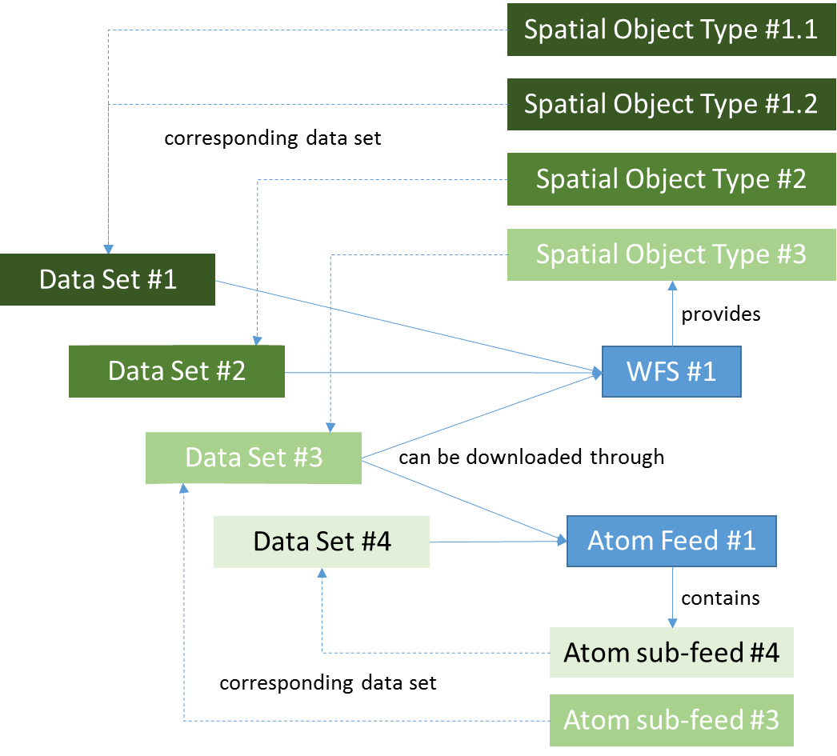
Data set #1 (pre-defined dataset download and direct access through WFS)
- Resource locator #1
  - URL: WFS #1 GetCapabilities request
  - protocol: OGC:WFS-2.0.0
  - application profile: download
- Resource locator #2
  - URL: GetFeature request with stored query for data set #1
  - protocol: OGC:WFS-2.0.0-get-feature
  - application profile: pre-defined-dataset-download
- Resource locator #3
  - URL: GetFeature request with spatial object types 1.1 and 1.2
  - protocol: OGC:WFS-2.0.0-get-feature
  - application profile: direct-access-download
Data set #2 (pre-defined dataset download and direct access through WFS)
- Resource locator #1
  - URL: WFS #1 GetCapabilities request
  - protocol: OGC:WFS-2.0.0
  - application profile: download
- Resource locator #2
  - URL: GetFeature request with stored query for data set #2
  - protocol: OGC:WFS-2.0.0-get-feature
  - application profile: pre-defined-dataset-download
- Resource locator #3
  - URL: GetFeature request with spatial object type 2
  - protocol: OGC:WFS-2.0.0-get-feature
  - application profile: direct-access-download
Data set #3 (pre-defined dataset download through Atom, direct access through WFS)
- Resource locator #1
  - URL: WFS #1 GetCapabilities request
  - protocol: OGC:WFS-2.0.0
  - application profile: download
- Resource locator #2
  - URL: Atom feed #1
  - protocol: WWW:LINK-1.0-http-atom
  - application profile: download
- Resource locator #3
  - URL: Atom sub-feed #3
  - protocol: WWW:LINK-1.0-http-atom
  - application profile: pre-defined-dataset-download
- Resource locator #4
  - URL: GetFeature request with spatial object type 3
  - protocol: OGC:WFS-2.0.0-get-feature
  - application profile: direct-access-download
Data set #4 (only pre-defined dataset download through Atom)
- Resource locator #1
  - URL: Atom feed #1
  - protocol: WWW:LINK-1.0-http-atom
  - application profile: download
- Resource locator #2
  - URL: Atom sub-feed #4
  - protocol: WWW:LINK-1.0-http-atom
  - application profile: pre-defined-dataset-download

The following example describes a scenario where several data sets, e.g. at regional or municipality level, are distributed through one download service that aggregates all lower level data sets into a national or regional data set. In this case, the data made available by the service should be described through a data set metadata record, even if it only exists "virtually" as the data offered by the service.

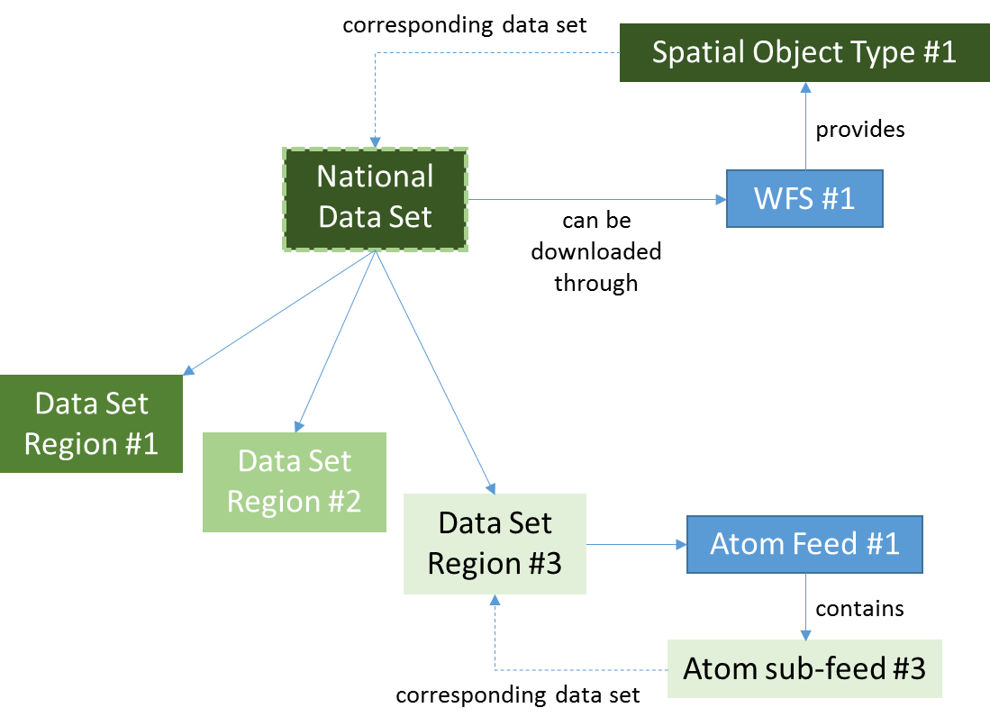
National data set (pre-defined dataset download and direct access through WFS)
- Resource locator #1
  - URL: WFS #1 GetCapabilities request
  - protocol: OGC:WFS-2.0.0
  - application profile: download
- Resource locator #2
  - URL: GetFeature request with stored query for the national data set
  - protocol: OGC:WFS-2.0.0-get-feature
  - application profile: pre-defined-dataset-download
- Resource locator #3
  - URL: GetFeature request with spatial object type 1
  - protocol: OGC:WFS-2.0.0-get-feature
  - application profile: direct-access-download
Data set region #1 and #2
- no resource locator or a resource locator pointing to the national data set
- Open issue: How to express the relationship to the national data set? Which options are offered by ISO standards? Which options are commonly implemented by tools? Should the relationship be expressed in each regional data set or in the national one or in both?
Data set region #3
- Resource locator #1
  - URL: Atom feed #1
  - protocol: WWW:LINK-1.0-http-atom
  - application profile: download
- Resource locator #2
  - URL: Atom sub-feed #3
  - protocol: WWW:LINK-1.0-http-atom
  - application profile: pre-defined-dataset-download
- Open issue: How to express that this data set is also shared through the national download service?

See e.g. the minutes of the 6th sub-group meeting: https://webgate.ec.europa.eu/fpfis/wikis/x/nZugE
https://ies-svn.jrc.ec.europa.eu/attachments/download/2516/%5BDOC14%5D_Discussion%20paper%20IR-MD_change%20proposal_v1.1.pdf
(a) keywords; (b) classification of spatial data and services; (c) the quality and validity of spatial data sets; (d) degree of conformity with the implementing rules on data interoperability; (e) geographical location; (f) conditions applying to the access to and use of spatial data sets and services; (g) the public authorities responsible for the establishment, management, maintenance and distribution of spatial data sets and services.
Precisely speaking, this data representation should be called "collection of spatial objects belonging to a certain spatial object type".
to be added to the INSPIRE registry as proposed in the change proposal at https://ies-svn.jrc.ec.europa.eu/issues/3257, e.g. http://inspire.ec.europa.eu/metadata-codelist/ProtocolValue/OGC:WFS-2.0.0
to be added to the INSPIRE registry, e.g. . http://inspire.ec.europa.eu/metadata-codelist/ApplicationProfile/view
e.g. GetFeature/GetMap with relevant feature types/layers

