**INSPIRE**

Infrastructure for Spatial Information in Europe

**Summary report of the 12th INSPIRE MIG expert group meeting, 26 and 27 November 2020, online meeting**

|  |  |
| --- | --- |
| **Title** | Summary report of the 12th INSPIRE MIG expert group meeting |
| **Creator** | DG ENV |
| **Date created** | 17-12-2020 |
| **Subject** | Summary report of the 12th MIG meeting |
| **Publisher** | EC and EEA INSPIRE Team |
| **Type** | Text |
| **Description** | Summary, conclusions and actions of the 12th MIG expert group meeting. |
| **Contributor** | EC INSPIRE TEAM |
| **Format** | MS Word (doc) |
| **Identifier** | Summary Report 12th MIG meeting |
| **Language** | En |
| **Status** | Draft |

# Approval of the agenda and of the minutes of previous meeting

*The meeting was opened by Robert Konrad, Head of DG ENV Unit E.4* *Compliance and Better Regulation and chaired by Joeri Robbrecht (ENV.E.4).*

The Commission presented the meeting agenda ([DOC1](https://webgate.ec.europa.eu/fpfis/wikis/download/attachments/356262712/%5BDOC1%5D_MIG10_Agenda_draft%20final.pdf?version=1&modificationDate=1560512997820&api=v2)) and the summary of the previous meeting ([DOC2](https://webgate.ec.europa.eu/fpfis/wikis/download/attachments/356262712/%5BDOC2%5D_MIG10_Summary%209th%20MIG%20Brussels_final.pdf?version=1&modificationDate=1560513042009&api=v2)). The MIG had no comments on the meeting agenda and was invited to provide feedback in writing on the minutes of the 11th meeting of the MIG by the 4th of December 2020.

All meeting documents and presentations have been made available on the collaboration platform of the INSPIRE Maintenance and Implementation expert Group (MIG)*[1]*.

*Conclusions and Actions*

*The meeting agenda and summary of the previous meeting were adopted.*

*The MIG was invited to provide feedback in writing on the minutes of the 11th meeting of the MIG by the 4th of December 2020.*

# Nature of the meeting

The meeting was a non-public meeting and was attended by nominated experts of 26 EU Member States (MS), Norway, Iceland, the Commission Services (ENV, JRC, ESTAT, AGRI, CNECT) and the European Environment Agency (EEA). Italy was not represented.

# List of points discussed

## Update on Commission initiatives (Information and discussion)

*Introduction*

The Commission presented information document ([DOC3](https://webgate.ec.europa.eu/fpfis/wikis/download/attachments/356262712/%5BDOC3%5D_MIG10_Update%20on%20Commission%20initiatives%20v1.1.pdf?version=1&modificationDate=1561012421915&api=v2)) and informed the MIG about the following ongoing Commission initiatives:

* GreenData4All
* Reportnet 3.0
* INSPIRE Conference 2021
* Funding instruments

The Commission presented the status of the evaluation of the INSPIRE Directive. An open public consultation and targeted consultations are foreseen to take place in March-May 2021.

The European Environment Agency (EEA) informed the MIG about the status of Reportnet 3.0 and pilot reporting data flows. Reportnet 3.0 went life on 31 July 2020. The first regulatory reporting flows that will completely run on this new system will be the Greenhouse gas Monitoring Mechanism Regulation (MMR) and the Environmental Noise Directive.

It was still unclear if the physical part of the INSPIRE Conference 2021 in Dubrovnik can take place seen the COVID-19 situation. Ultimately the INSPIRE Conference 2021 will again be organised as a full online conference.

The Commission informed the MIG about current and emerging funding opportunities, notably under HORIZON 2020 (European Green Deal call), HORIZON EUROPE, the Digital Europe Programme (DEP) and the Recovery and Resilience Facility.

*Conclusions and Actions*

*The Commission will keep the MIG informed on any progress made on the presented initiatives.*

*The MIG was invited to share the information with relevant colleagues and communities.*

## Monitoring and reporting 2020 (Information and discussion)

*Introduction*

The Commission presented the background and status of the monitoring and reporting process for 2020. Main change compared to last year is the transition to metadata encoded following the updated metadata technical guidance MD TG 2.0. The reference validator will only validate metadata according to MD TG 2.0, the geoportal will still be able to support MD TG 1.3. The version of the INSPIRE reference validator released on 16 September 2020 is the one that will be used to test compliance for the 2020 monitoring and reporting cycle.

The Commission advised to use a local instance of the INSPIRE reference validator to avoid overloading the central online validator and gave an overview of the calculation of the indicators.

The visualization of the monitoring and reporting 2020 dashboard will be optimized to better reflect country progress made. A star-based score system will be used to show the overall performance for each indicator and a symbol which immediately shows whether the value has increased, decreased or has remained the same as last year will be included.

A JRC Technical Report on the 2019 monitoring and reporting cycle[2] will be available soon.

*Discussion*

An expert raised possible issues with local installation of the INSPIRE validator on networks with limited internet access. Another expert asked if the validation report documents the validation errors per dataset or service or just as a summary.

The Commission replied that the source code of the validator and a Docker image are available. This should allow for supporting the local context. In case of issues with local proxy configurations, they need to be solved locally. The MIG experts were asked to document any possible issues on the helpdesk. The Commission will try to provide suggestions and support.

The Commission further explained that you can also run validation on a local set of metadata (metadata in local folders). The output files give you information on which metadata failed which test. You also get a summary file that gives an overview on how many metadata failed which test.

*Conclusions and Actions*

*The MIG was invited to report any remaining Monitoring and Reporting issues on the INSPIRE helpdesk[3].*

## Good implementation practices (D/E)

*Introduction*

The Commission was asked to investigate the possible interplay and the legal coherence between the implementing obligations of the INSPIRE Directive and good practices. Answer is that the legislation has not changed and still needs to be implemented in full as it is right now. Good practices cannot amend, change or interpret legislation in any form they can only refer to technical implementations that satisfy the existing legal requirements using the flexibility of the legal framework. To guarantee legal compliance every good practice should be scrutinized on its legal conformity.

**OGC API features & OGC SensorThings API**

The Commission presented the “OGC API features” and “OGC SensorThings API” good practices. The good practice on OGC API-features was developed under MIWP action 2020.1 in collaboration with experts from 15 Member States. A workshop was organised on 6 November 2020 to reach out to the community. The workshop was attended by 185 registered attendees. Ample evidence of implementation in several Member States was given (Germany, Finland, France, Italy).

The OGC SensorThings API good practice was pitched and discussed at the 63rd MIG-T meeting. The API is fit for multiple Internet of Things (IoT) use cases and provides a powerful and at the same time a simple way for exposing and consuming spatio-temporal data. The good practice is made available on github[4]. A mapping is provided on how to use the standard as a download service but also how to encode data according to the environmental monitoring facility and observational model in INSPIRE. Outreach was organised as a workshop with 80 registered attendees and a hands-on session on how to work with the API. Existing deployments as evidence of implementation could be found in Austria (Air Transport Information), Germany (Urban Data Platform Hamburg) and as part of ad-hoc COVID-19 data sharing.

*Discussion*

A MIG expert inquired how to fulfil INSPIRE metadata obligations when using SDMX. The Commission explained that SDMX has the advantage that the data is already structured in a harmonised way. For full INSPIRE compliancy, SDMX needs to be amended with additional metadata elements. This is being done for the upcoming census grid data dissemination were the SDMX data components have been enhanced with the required INSPIRE metadata elements (see <https://webgate.ec.europa.eu/sdmxregistry> for the census 2021 grid definition).

***The MIG endorsed the “SDMX for Human Health and Population Distribution good practice”.***

MIG experts proposed to continue the work on the OGC API Features good practice with the new coordinate reference system standard and update the good practice once the work is finalised. The Commission agreed to consider the good practice as a living document and to integrate future developments in the good practice.

***The MIG endorsed the “OGC API-Features” and the “OGC SensorThings API”.***

Furthermore, it was suggested by a MIG expert to further develop the simplification of data and service linking as a good practice in 2021. The Commission welcomed the proposal.

*Conclusions and Actions*

*Subject to an assessment of their compliance with the INSPIRE legal framework, the MIG has endorsed three good implementation practices:*

*- “SDMX for Human Health and Population Distribution”;*

*- “OGC API -Features";*

*- and "OGC SensorThings API".*

*It was agreed to further develop the simplification of data and service linking as a good practice in 2021.*

## Maintenance and Implementation Work Programme

The colleagues from EEA and JRC have provided us with a full update on the ongoing actions under the current MIWP that included: the work on the priority list of data sets for e-reporting, the reference validator, the geoportal, the registry and theme specific issues. We also got a flavour of the preparatory actions to support the transition from the current to the new work programme. The MIG was kindly invited for the [*INSPIRE Community Forum Webinar on Friday 11 December 2020*](https://inspire.ec.europa.eu/events/inspire-community-forum-webinar).

### MIWP Action progress, review and discussion including agreement of next steps

#### a) 2016.5 Priority list of e-reporting data sets: status update and monitoring of progress (I/D)

*Introduction*

The European Environment Agency (EEA) updated the MIG on the progress of MIWP action 2016.5 and the performance of the Member States in making priority e-Reporting data sets available ([DOC5](https://webgate.ec.europa.eu/fpfis/wikis/download/attachments/356262712/%5BDOC5%5D_MIG10_2016.5_Priority_%20list_data_sets.pdf?version=1&modificationDate=1560513141396&api=v2)a).

Only one EU Member State (Ireland) is still without any download services. Eight EU Member States (Croatia, Cyprus, Estonia, Hungary, Italy, Poland, Romania and Slovenia) provided ten or less downloadable datasets. In general there was still an overall lack of download services.

On the common and interoperable European data models on overview was given of the already harmonized data models used in reporting flows (CDDA, EU Registry, Invasive Alien Species, ongoing work on Floods and Noise Directives). More information is available on the subgroup wiki[5].

The new geoportal function to monitor priority data sets by environmental domain was presented.

*Discussion*

The MIG asked the Commission and the EEA to keep informing the expert group and the 2016.5 subgroup on emerging reporting streamlining initiatives.

The EEA and the Commission agreed to keep the 2016.5 subgroup and the MIG informed about planned Reportnet 3.0 harmonized reporting flows (e.g. Drinking Water Directive).

*Conclusions and Actions*

|  |
| --- |
| *The implementation progress on the priority list of e-reporting data sets is still unsatisfactory. The amount of identified data sets has increased. The accessibility of the data sets is lagging behind.*  *The EEA and the Commission agreed to regularly update the 2016.5 subgroup and the MIG on*  *reporting harmonisation and streamlining initiatives.* |

#### b) Geoportal, Reference Validator and Registry (I/D)

#### *Introduction*

The Commission presented the progress and ongoing activities on the Geoportal, the INSPIRE Reference Validator and the Registry *(*[*DOC5b*](https://webgate.ec.europa.eu/fpfis/wikis/download/attachments/596018902/%5BDOC5b%5D_MIG_12_MIWP.pdf?version=1&modificationDate=1605804135077&api=v2)*).* New Abstract Test Suites and Executable Test Suites are being developed for INSPIRE Annex II and III data specification. The tests are made available in staging for testing on GitHub. For the INSPIRE Reference Validator a new interface has been developed and test in collaboration with the INSPIRE validation community. The interface now provide a simplified workflow for validating data, services and metadata. A network of National Contact Points on validation was set up. 21 experts from 14 countries joined the network and a kick-off meeting was held on 14 July 2020.

The new version of the Re3gistry software (v2.0) was released on 20 July 2020. The interface has been made more user-friendly and has been extended with a REST API. The software was officially published as open source under EUPL 1.2 and will be included in the OSGeo Live software v.14 that will be released late 2020. The use of the Re3gistry software is further promoted through the INSPIRE Register Federation testbed and already includes 10 federated registries.

*Discussion*

MIG experts informed about the transition of INSPIRE resources from HTTP to HTTPS and raised that the deadline of March to make necessary changes to metadata and services by March 2020 is not feasible. The Commission answered that the deadline is an internal security deadline for Commission services and is happy to discuss with implementers and service providers on a feasible way forward.

*Conclusions and Actions*

|  |
| --- |
| *The MIG took note of the information shared by the Commission.* |

#### c) 2016.4 Theme specific issues (I/D)

*Introduction*

The Commission presented the status of activities on theme specific issues ([DOC5b](https://webgate.ec.europa.eu/fpfis/wikis/download/attachments/596018902/%5BDOC5b%5D_MIG_12_MIWP.pdf?version=1&modificationDate=1605804135077&api=v2)). The Commission will continue to support sharing of implementation experiences and information on relevant EU projects and activities. The current existing technical solution is outdated. Technical and legal questions will be migrated to the common INSPIRE Helpdesk hosted on GitHub. Discussions will be migrated to a new platform (e.g. GIS Stack Exchange). Several newsletters have been published (summer, autumn, winter 2020).

The MIG was kindly invited for the INSPIRE Community Forum Webinar[6] on Friday 11 December 2020. The Webinar is open for all and driven by the facilitators. Achievements, practical implementations and use cases will be presented.

*Discussion*

The MIG had no questions or comments on the presented information.

*Conclusions and Actions*

|  |
| --- |
| *The MIG took note of the information shared by the Commission.*  *The MIG was kindly invited for the* [*INSPIRE Community Forum Webinar on Friday 11 December 2020*](https://inspire.ec.europa.eu/events/inspire-community-forum-webinar)*.*  *The MIG was invited to share the information on the webinar with their network.* |

#### d) Transition to Work Programme 2020-2024 (I/D)

*Introduction*

The Commission presented their plans for guaranteeing business continuity and sustainability of the INSPIRE core infrastructure components ([DOC5b](https://webgate.ec.europa.eu/fpfis/wikis/download/attachments/596018902/%5BDOC5b%5D_MIG_12_MIWP.pdf?version=1&modificationDate=1605804135077&api=v2)). The central INSPIRE components (such as the Geoportal, Reference Validator, Re3gistry, Knowledge Base) and their helpdesks were conceptualised and developed in slightly different contexts, using different technologies, and in different periods. While there is evidence for the usefulness of all those components by the INSPIRE community, operating and maintaining them through the current approach is not feasible from a financial and organisational point of view.

The Commission is working on a common approach that would ensure the sustainability of all the components in the long term and avoid the discontinuation of the services that they offer. The foreseen common approach is based, for each of the central components, on the following high-level principles:

* adequate governance body;
* establishment of strategic partnerships with selected software projects and communities that would help ensure sustainability (e.g. open source communities);
* minimisation of own developments and custom extensions in favour of increased reliance on already existing solutions;
* decoupling of the software components from the JRC ICT infrastructure;
* extensive use of GitHub as the Git-based platform for collection, discussion and resolution of technical issues, as well for migrating the different helpdesks related to INSPIRE components (Geoportal, Registry, Validator).

*Discussion*

A MIG expert inquired if there are any discussions on EU-level about transferring support tasks to the upcoming Data Support Centres for the European Data Spaces.

The Commission answered that these Data Support Centres are a work in progress and need to be further crystallized before any discussion can take place on transferring support tasks. Moreover, the Commission stated that there is a good collaboration with other Commission Services working on digital initiatives on streamlining and aligning activities. Furthermore, the aforementioned high-level principles will still hold independent whether tasks are transferred to the Data Support Centres or not. Main principles are not to setup parallel development activities, reuse as much as possible available de facto software and build strategic partnerships with the development communities. GeoNetwork open source software is a good example. It is part of the Open Source Geospatial Foundation (OSGeo) and already used by 14 Member States, several Commission Services and the FAO.

*Conclusions and Actions*

|  |
| --- |
| *The MIG took note of the information shared by the Commission.* |

## Work Programme 2020-2024 (I/D/E)

*Introduction*

The Commission thanked the MIG, the MIG-T experts and the colleagues from Commission and EEA for the feedback received on the draft Work Programme 2020-2024 and the progress made on the document. The Commission presented the updated document, the main objectives, the areas of work and the core actions for discussion and possible endorsement by the MIG.

*Discussion*

German, Austrian and French MIG experts took the floor expressing their support for the new Maintenance and Implementation Work Programme 2020-2024 (MIWP 2020-2024). The document was considered very well aligned and interlinked with European digital strategies and initiatives and the timing is right to jump on the digital high-speed train. The core MIWP principles that steer the implementation towards a digital ecosystem that addresses clearly defined EU wide needs, is based on proven standards and technologies, can be implemented in a foreseeable time with limited effort and has a built-in review cycle, was highly welcomed. The last 4 years the MIG stakeholders have collaborated in a productive way with tangible results. This level of collaboration and the transparency between the Commission and the MIG has established a trust relationship that should be continued in the future.

The MIG asked for further clarification on the interplay between the INSPIRE Directive, the EU Data Strategy and the Open Data Directive and the role of the INSPIRE MIG expert group in this.

The Commission explained that these interlinkages between the MIG and the other government structures (Support Centres for Dataspaces, Data Innovation Board for the governance of the dataspaces, Open Data committee …) that are being set up need to be developed. Building relations and collaborating with these other government structures will be an important activity to channel input from our domain into the wider digital discussions and vice versa. Regarding the legal framework, a number of digital acts have been adopted or are being prepared that might affect the INSPIRE Directive. One of these is the act on the governance of European data spaces and the other one that will have an impact is the implementing act on High Value Data sets under the Open Data directive. The governance act tries to lay down a number of horizontal rules that should make it easy for businesses to share data with each other, for citizens to share data for the common good and also establishes a Data Innovation Board. Interaction with this governance regulation should be on the level of the Data Innovation Board. This will be an expert group to advise the commission on the need for standardisation and interoperability between the different data spaces that will be established for the different sectors. The draft legal act for the High Value Data sets under the Open Data Directive references INSPIRE for part of its implementation. The main thing the draft legal act is adding is an obligation on licensing (open data). The Commission services and EEA have paid great attention to avoid overlaps and be as complementary as possible. It will be important to structure the collaboration with the Open Data Committee (formally responsible for the implementing act on High Value Data sets) on data sharing issues. The Commission will liaise with colleagues working on these files, but the Member States and MIG experts will also have to work on MS level to establish the link between communities.

**After the discussion the Chair moved to the formal endorsement of the MIWP 2020-2024.**

**The MIG endorsed the MIWP 2020-2024 unanimously.**

After a long maturing process, the MIG has endorsed an ambitious and forward-looking new multi-annual work programme 2020-2024 that will render the Directive and its implementation into a valuable instrument in support of the green and digital transformation. Many thanks to all MIG experts and colleagues for their contributions and continuing commitment and support. With this, the work for the MIG is cut out for the coming years and the Commission will start preparing the kick-off for the actions and the further transition from the current to the new Work Programme.

Seen the multitude of ongoing and planned activities in support of twin green and digital transformation it is not always easy to grasp the interlinkages or tie all the individual actions together into a larger picture. To facilitate a common understanding, the Commission has promised to prepare a comprehensive overview of this new and emerging landscape.

*Conclusions and Actions*

|  |
| --- |
| *The MIG has endorsed an ambitious and forward-looking new multi-annual work programme 2020-2024 that will render the Directive and its implementation into a valuable instrument in support of the green and digital transformation. Many thanks to all MIG experts and colleagues for their contributions and continuing commitment and support.*  *The Commission and the EEA will take the necessary actions to organise the transition from the previous work programme to the new work programme and initiate the actions.*  *The Commission will prepare a comprehensive, visual overview of the emerging digital landscape.* |

## Spatial data governance at EU level

*Colleagues from DG CNECT and DG AGRI shared information on the status of the Implementing Act on the High Value Datasets and IACS data sharing. Their interventions showed the relevance of INSPIRE as an instrument to organise and implement data sharing across different domains and future European common data spaces. DG CNECT invited the MIG to reach out to the open data community and share possible issues with them in making selected HVD that are in scope of INSPIRE available as open data. DG AGRI invited the MIG to support the CAP paying agencies on the INSPIRE-based implementation of IACS data sharing.*

### Implementing act on high-value datasets under the Open Data and Public Sector Information (PSI) Directive (State of Play).

*Introduction*

The Commission (DG CNECT) presented the European Strategy for Data with special attention for the draft Implementing Act on High-Value datasets under the Open Data Directive ([PRES_HighValueDS](https://webgate.ec.europa.eu/fpfis/wikis/download/attachments/596018902/MIG12_HighValueDatasets.pdf?version=1&modificationDate=1606478470918&api=v2)).

The Commission published an EU Data Strategy in February 2020 to address the lack of data available for reuse, lack of European data processing and storage solutions, absence of comprehensive data governance approaches and lack of data portability mechanisms. One of the important concepts put forward in the data strategy was the common European data spaces. The data spaces consist of physical infrastructure but also of governance principles and access policies to support free flow of data across different sectors. A quick and comprehensive overview of concrete legislative initiatives was given. On 25 November 2020 the Commission adopted the proposal for a “Data Governance Act”. This legislation improves the governance of data spaces through a data altruism mechanism, allows to share private data for a societal benefit, provides for a mechanism that will increase trust in data intermediaries and a provides a mechanism to get conditional reuse access to non-public governmental data. There will be also a European expert group to give recommendations on the use of standards and interoperability. In Q4 2020 also the Digital Market Act, which will deal with data held by online platforms, is planned for adoption. For Q2 2020 the adoption of the implementing act on High Value data sets under the Open Data Directive is planned. The last legal initiative will be the Data Act in Q3 2021 that will look at the rights over data when they move between business players (e.g. IoT applications, industrial data). The Data Act will also look into B2G data sharing, how to make it easier for companies to share their data with the public sector. This year the focus was on the definition of the list of High Value Datasets. There was a public consultation, an impact assessment and discussions with Member States in the Open Data Committee. The proposal for the list of High Value Datasets will be submitted to the Open Data Committee in Q1 or Q2 2021. The High Value datasets will be machine-readable, free and available through APIs including for bulk download. Six categories of High Value Data are prescribed in the Open Data Directive. Most relevant categories for the MIG are “Geospatial”, “Earth Observation and Environment” and “Mobility”. The Impact Assessment recommended less ambitious requirements for “’Geospatial” and “Mobility”, and more ambitious for “Earth Observation and Environment”.

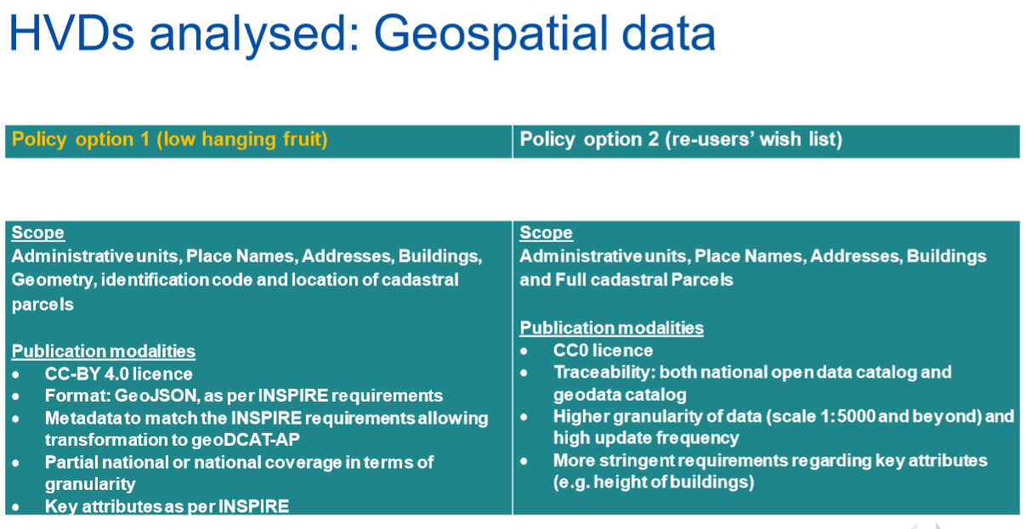

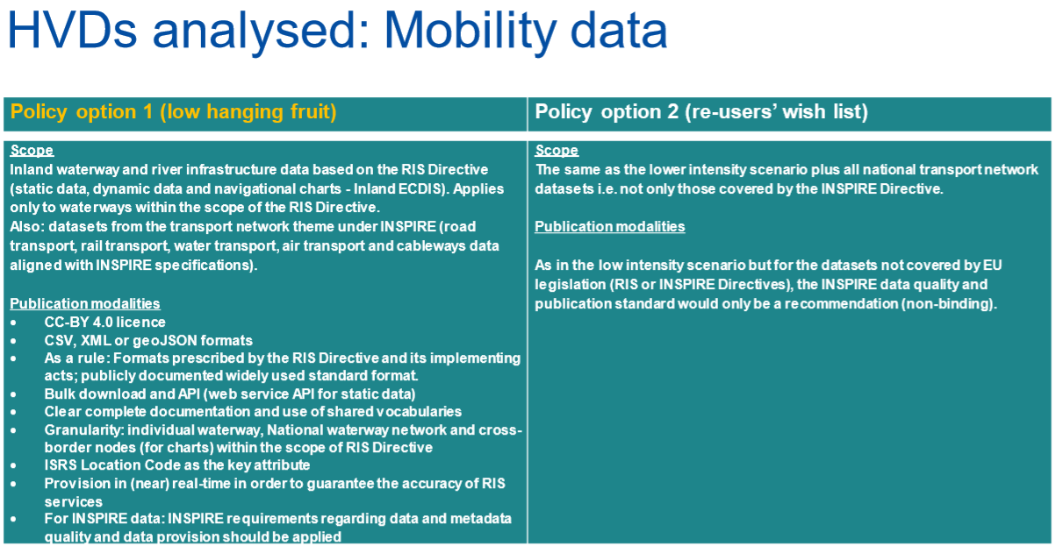

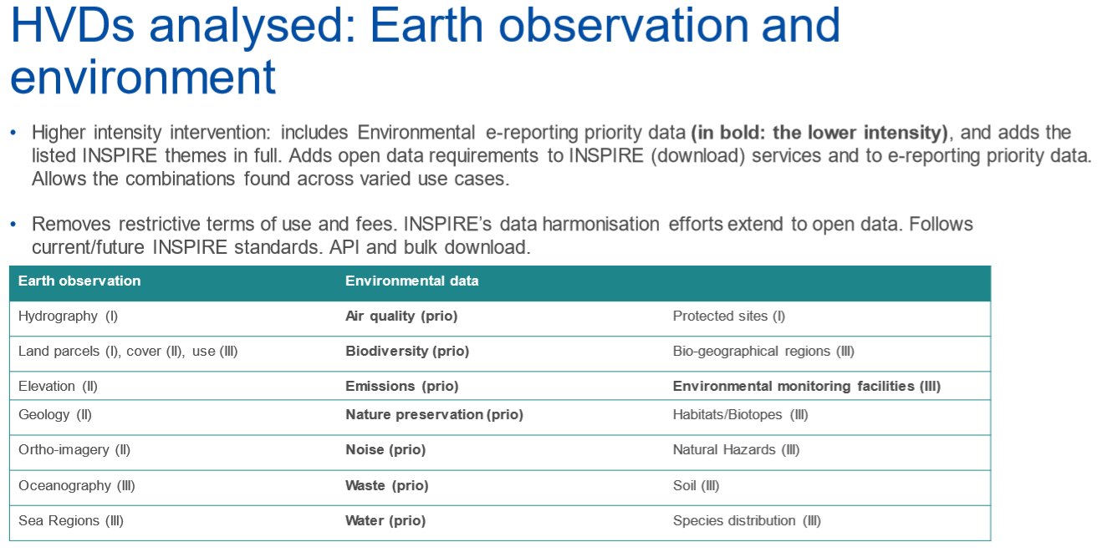

The Commission ended the presentation with an overview of open data building blocks and funding possibilities under the Digital Europe Programme (DEP) to support making the high-value datasets available.

A sli.do survey was used to poll for MIG experts opinion and expectations on several aspects of the implementing act on High Value data sets. The complete survey and the results are annexed to these minutes (See Annex 1).

In general the MIG welcomed the High Value Data sets initiative and expect it to be beneficial to the implementation and the strengthening of the INSPIRE Directive. Half of the respondents expect problems with making the selected data sets available as open data. Specifically the Annex I and III reference data (addresses, cadastral parcels, transport networks, buildings …) are expected to create problems. Only 18% of the respondents is already planning to use the DEP funding instrument for publishing data from all three INSPIRE Annexes (Annex I & III reference data 63%, Annex II reference data 47%, Annex I & III thematic data 63%). It will be important to facilitate INSPIRE implementers and promote DEP calls.

The Chair thanked DG CNECT for the presentation and opened the floor for questions.

*Discussion*

The presentation kicked-off a vivid discussion. Several questions were raised by MIG experts and Commission services:

* Why is the Data Act only addressing business, not science or citizen science or even citizens as the ones who use smart devices with sensors (private weather stations, cars with emission sensors, ...) which would be valuable for policy making as well?
  + Commission: The Data Act will only be taking shape in the months to come with a planned adoption data towards the end of 2021. It is difficult to say at this moment what it will contain. The Data Governance Act already provides for several mechanisms that make it easier for individuals or public sector bodies to make their data available for e.g. research.
* Will it be mandatory to serve data in the GEOJSON format?
  + Commission: This would be mandatory in the sense that we will be imposing a format used under INSPIRE to avoid duplication. At the same time, we do not want to be very prescriptive on the technical implementation details and leave room for community standards and technical evolution. We will formulate this provision in a more generic way to allow some preferred format or and equivalent format that facilitates data sharing.
* What do “full cadastral parcels” mean?
  + Commission: Full cadastral parcel also includes the legal ownership part. This information was part of the more ambitious option, which will not be followed.
* Some of the INSPIRE spatial data are common or fundamental data that is used in many domains. How do we avoid enclosure in an environmental silo and make sure the data flows freely between different sectors and data spaces?
  + Commission: That is the objective of the Implementing Act on High Value datasets (HVD). We hope that once these fundamental data are on the list of HVD, they will be freely reusable by anyone for any purpose. At the same time, we should underline that even if data does not make it on the list of HVD, it would still be good practice if Member States make them available as open data.
* INSPIRE is a basic component for geospatial data in the implementing act on High Value datasets. On the other hand, the open data portal is promoted. Open data has a reduced set of MD (compared to INSPIRE). In order to provide for both directives, the geospatial domain has to duplicate its efforts in satisfying both INSPIRE and Open Data metadata requirements. What we see for the moment is duplication of INSPIRE metadata sets on the open data portal and the tendency to articulate specific Open Data obligations in national law. How can we avoid this?
  + Commission: The Open Data directive does not impose a concrete metadata format. On the High Value Datasets there will be some metadata obligations, but they will be aligned with INSPIRE. For INSPIRE data sets you will have to follow the INSPIRE requirements and then you will be in line with the open data requirements. The requirements put forward by the European (open) data portal are not legal obligations. Diverging obligations on the same data is bad practice and should be avoided. On EU level, it is clear that we will base ourselves on the INSPIRE requirements. How legislation is transposed into national legislation is within the competence of national public bodies.
* How will the governance being setup for the High Value data sets and the Data Governance Act (Data Innovation Board, Support Centre for Data spaces) link to the governance of more thematic data legislation such as INSPIRE and more specific the MIG expert group?
  + Commission: The European Innovation Board will look at concrete sectors and explore if there are standards that need to be created or promoted to put the necessary rules in place to e.g. guarantee data holder/owner rights. Many sectors can benefit from this. The geospatial sector is already very advanced on the use of standards and will rather serve as a model. The situation is also a bit simpler, since the holders are typically public sector bodies. On the other hand, there might be some topical questions where this governance mechanism might be helpful. Regarding the interlinkage of governance structures, i.e. linking INSPIRE MIG to Open Data Committee, these are two governance bodies with clear competences that should play their governance role within their competence. The Open Data Committee on the more generic level of the Implementing Act on High Value datasets and the INSPIRE MIG on the sectoral level of data in scope of the INSPIRE Directive. The collaboration on EU level has been very good and we would ask the Member States to strengthen the link between the INSPIRE community and the Open Data community on national level. In some Member States this is already established. To make sure all aspects of the High Value datasets will be discussed in the Open Data Committee, the Commission invited the MIG to reach out to the representative of their national open data policy and share possible issues with them in making selected High Value Data that are in scope of INSPIRE available as open data.
* As final question, clarification was asked on sensitive data, industry secrets and all other concepts that might hamper making data available as open data and the building of a functional data ecosystem in the EU.
  + The Commission replied that on the supplier side, this is partly covered by the data altruism mechanism in the Data Governance Act where you can make your personal sensitive data available for some public goal. It is also covered by the proposed mechanism for accessing and reusing sensitive data held by public sector already today (e.g. data from the health sector). Industry secret related issues will be covered by the B2B mechanism in the Data Act planned for next year.

*Conclusions and Actions*

|  |
| --- |
| *DG CNECT invited the MIG to reach out to the representative of their national open data policy and share possible issues with them in making selected HVD that are in scope of INSPIRE available as open data.*  *The Commission will keep the MIG informed on any progress made on the EU Data Strategy and related initiatives.* |

### Development of the Green Deal dataspace

*Introduction*

The Commission presented the status on the development of the Green Deal dataspace. Under the Digital Europe Programme (DEP), the total budget available for the first two years is EUR 2.8 billion and will be used to finance two major initiatives that will contribute to the development of a European Green Deal data space: a large scale action to support climate-neutral and smart communities in their digital enabling of the Green Deal priorities and the circular economy transition starting with the urban level. Furthermore, calls will go out under the DEP for the development of Destination Earth and for a Coordination Action on Digital Product Passport that will prepare the ground for a future common European data space for smart circular applications.

*Discussion*

A MIG expert asked about the planning and the requirements of the digital twins under Destination Earth. More clarity could help aligning national initiatives with European ones.

The Commission clarified that the Destination Earth is still in a early state. The two first digital twins for which will go out calls for proposals will be focused on extreme weather events and climate adaptation. More information on the identified Destination Earth use cases at <https://ec.europa.eu/jrc/en/publication/destination-earth-use-cases-analysis>. The Commission will keep the MIG informed on any progress.

*Conclusions and Actions*

|  |
| --- |
| *The Commission will keep the MIG informed about the progress on the development of the Green Deal data space and the Destination Earth initiative.* |

### DG AGRI Process for IACS data sharing under INSPIRE (State of Play)

*Introduction*

The Commission (DG AGRI) presented the background and the progress on the implementation of the IACS data sharing process. The action has to be seen under the Green Deal “Farm to Fork” strategy and has the ambition to break the silos between different thematic communities, notably agriculture-climate-environment. The initiative is executed in collaboration with different EC services and the Paying Agencies in the Member States. They will work together on the discoverability and interoperability of IACS data, demonstrate the use of the data through practical examples (e.g. soil health) and explore potential new uses for the data. A first mapping of existing IACS data sharing in the Member States showed that a majority of Member States already share agricultural parcel data (e.g. crops) to some extent. The INSPIRE Directive will allow an efficient way to exchange, share, access and use IACS spatial data. The Commission (JRC) has already developed several guidelines on publishing IACS data following INSPIRE specifications. To make this data sharing effort a success, the support of the Member States is essential and synergies will be sought with other projects (e.g. OpenIACS, NIVA …) and the INSPIRE community. The MIG experts were invited to reach out to the paying agencies in their country to support the IACS data sharing initiative.

The Chair thanked DG AGRI for the presentation and opened the floor for questions.

*Discussion*

The MIG had no questions or comments on the presented information.

*Conclusions and Actions*

|  |
| --- |
| *The MIG took note of the information shared by the Commission.*  *The MIG experts were invited to reach out to the paying agencies in their country to support the IACS data sharing initiative.* |

## Exchange of experiences and good practices by Member States.

An expert from the German INSPIRE coordination team together with the Commission presented the Franco-German GAIA-X initiative to build a federated data infrastructure for Europe. A [video](https://youtu.be/qzkej232ItQ)[7] introducing the GAIA-X initiative was shown, followed by presentations on the governance of this initiative, first experiences with the GAIA-X community and the possible role of GAIA-X in INSPIRE implementation. To further explore the possible role of GAIA-X, the Commission proposed to organise a dedicated workshop on GAIA-X and INSPIRE.

*Discussion*

Due to time constraints, it was not possible to have a discussion on the topic. The MIG was kindly invited to watch out for the GAIA-X workgroup invitation where the topic will be explored in detail and ample time will be available for questions and discussions.

*Conclusions and Actions*

|  |
| --- |
| *The MIG took note of the information shared by the Commission.*  *To further explore the possible role of GAIA-X, the Commission proposed to organise a dedicated workshop on GAIA-X and INSPIRE.* |

## News from the standardisation bodies (Information)

*Introduction*

The Commission shared an information document ([DOC7](https://webgate.ec.europa.eu/fpfis/wikis/download/attachments/596018902/%5BDOC7%5D_MIG12_News%20from%20Standardisation%20Bodies.pdf?version=1&modificationDate=1605804212781&api=v2)) and presented new developments and activities relevant to INSPIRE maintenance and implementation from the following standardisation bodies: “ISO/TC 211”, “Open Geospatial Consortium (OGC)” and “World Wide Web Consortium (W3C)”. The MIG members were invited to distribute this information among their networks and share any feedback or questions on the presented topics with the EC INSPIRE team.

*Discussion*

Due to time constraints, it was not possible to have a discussion. The MIG was invited to share the information with their network.

*Conclusions and Actions*

|  |
| --- |
| *The MIG took note of the information shared by the Commission on new developments and activities by relevant standardisation bodies.*  *MIG experts were invited to share this information in their networks and discuss possible coordinated actions related to the presented standardisation activities.* |

## Any Other Business

The Austrian MIG expert shared information on an ISO TC211 activity, which evaluates non-relational databases and their impact on ISO standards. More information can be found at <https://github.com/ISO-TC211/NonRelationalDBTech>. The MIG was kindly invited to share any use cases, experiences and/or feedback.

The Commission informed the MIG about an upcoming (3 December 2020) [ELISE webinar](https://joinup.ec.europa.eu/node/703535) “Using synonyms to improve discovery of geospatial data” under the umbrella of the ISA² programme. The webinar will share findings of a study on how to use semantic interoperability to improve the retrieval of geospatial data. INSPIRE was used as a reference in the study and the INSPIRE geoportal as a case study. More information is available at [*https://joinup.ec.europa.eu/node/703535*](https://joinup.ec.europa.eu/node/703535). The MIG experts was kindly invited to join the webinar.

# Conclusions/recommendations/opinions

These are the highlights of the 12th meeting of the INSPIRE Maintenance and Implementation Group (MIG) that took place on 26 and 27 November 2020. It was an intensive and interactive meeting with a variety on discussed topics stretching from political to technical and from focused INSPIRE items to the broader digital and green deal agenda.

The MIG approved the meeting agenda and was kindly invited to provide feedback in writing on the minutes of the 11th meeting of the MIG by the 4th of December 2020.

The Commission informed the MIG about the political evolution, ongoing INSPIRE evaluation, relevant initiatives of the European Commission and funding opportunities.

Subject to a detailed assessment of their compliance with the INSPIRE legal framework, the MIG has endorsed three good implementation practices:

* “SDMX for Human Health and Population Distribution”
* “OGC API -Features"
* and "OGC SensorThings API"

Besides a very helpful presentation on the preparation for the upcoming monitoring and reporting cycle, the colleagues from EEA and JRC have provided us with a full update on the ongoing actions under the current MIWP that included: the work on the priority list of data sets for e-reporting, the reference validator, the geoportal, the registry and theme specific issues. We also got a flavour of the preparatory actions to support the transition from the current to the new work programme. The MIG was kindly invited for the INSPIRE Community Forum Webinar on Friday 11 December 2020.

After a long maturing process, the MIG has endorsed an ambitious and forward-looking new multi-annual work programme 2020-2024 that will render the Directive and its implementation into a valuable instrument in support of the green and digital transformation. Many thanks to all MIG experts and colleagues for their contributions and continuing commitment and support. With this, the work for the MIG is cut out for the coming years and the Commission will start preparing the kick-off for the actions and the further transition from the current to the new Work Programme.

The colleagues from DG CNECT, DG AGRI and the German INSPIRE coordination team shared information on the status of the Implementing Act on the High Value Datasets, IACS data sharing and GAIA-X. Their interventions showed the relevance of INSPIRE as an instrument to organise and implement data sharing across different domains and future European common data spaces. Seen the multitude of ongoing and planned activities in support of twin green and digital transformation it is not always easy to grasp the interlinkages or tie all the individual actions together into a larger picture. To facilitate a common understanding, the Commission has promised to prepare a comprehensive overview of this new and emerging landscape. DG CNECT invited the MIG to reach out to the open data community and share possible issues with them in making selected HVD that are in scope of INSPIRE available as open data. DG AGRI invited the MIG to support the CAP paying agencies on the INSPIRE-based implementation of IACS data sharing.

A more detailed account of meeting discussions and conclusions per agenda item have been highlighted under 3) "List of points discussed".

Agenda, documents and presentations are available on [the collaboration platform](https://ies-svn.jrc.ec.europa.eu/projects/mig-p/wiki/8th_meeting_of_the_MIG)[8].

# Next steps / actions

***The MIG*** *was invited to:*

* Provide feedback in writing on the minutes of the 11th meeting of the MIG by the 4th of December 2020.
* To report any remaining Monitoring and Reporting issues on the INSPIRE helpdesk.
* Join the INSPIRE Community Forum Webinar on Friday 11 December 2020.
* to reach out to the representative of their national open data policy open data community and share possible issues with them in making selected HVD that are in scope of INSPIRE available as open data.
* To reach out to the paying agencies in their country to support the IACS data sharing initiative.
* To share any use cases, experiences and/or feedback on an ISO TC211 activity, which evaluates non-relational databases and their impact on ISO standards. More information can be found at <https://github.com/ISO-TC211/NonRelationalDBTech>.
* Join an upcoming (3 December 2020) [ELISE webinar](https://joinup.ec.europa.eu/node/703535) “Using synonyms to improve discovery of geospatial data” under the umbrella of the ISA² programme. More information is available at [*https://joinup.ec.europa.eu/node/703535*](https://joinup.ec.europa.eu/node/703535).

***The Commission*** *will:*

* Keep the MIG informed on any progress made on the presented Commission initiatives.
* Together with the EEA, regularly update the 2016.5 subgroup and the MIG on reporting harmonisation and streamlining initiatives.
* Together with the EEA take the necessary actions to organise the transition from the previous work programme to the new work programme and initiate the actions.
* Prepare a comprehensive, visual overview of the emerging digital landscape.
* Organise a dedicated workshop on GAIA-X and INSPIRE.

# Next meeting

The 13th Meeting of the INSPIRE Maintenance and Implementation expert Group is tentatively scheduled for Thursday 17 & Friday 18 June 2021. Taking into account the COVID-19 situation in Europe, this meeting will again be organised as an online meeting.

**Annex 1 : Spatial data governance at EU level – sli.do poll**

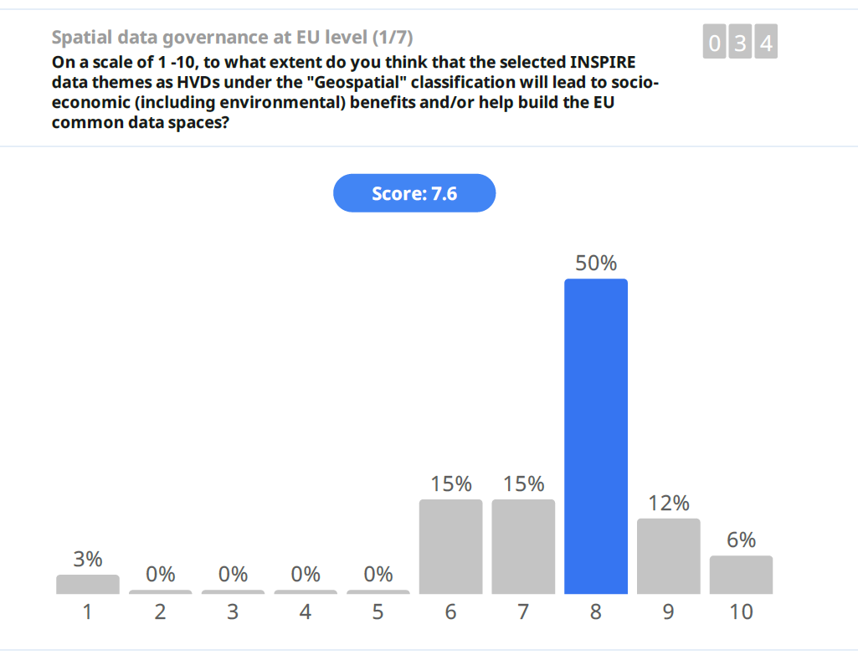

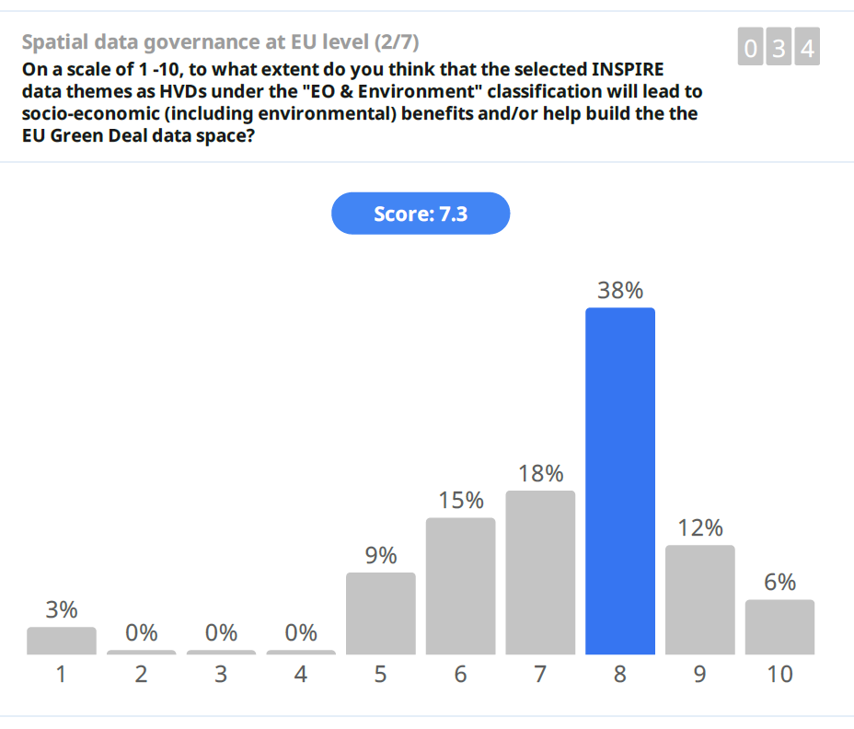

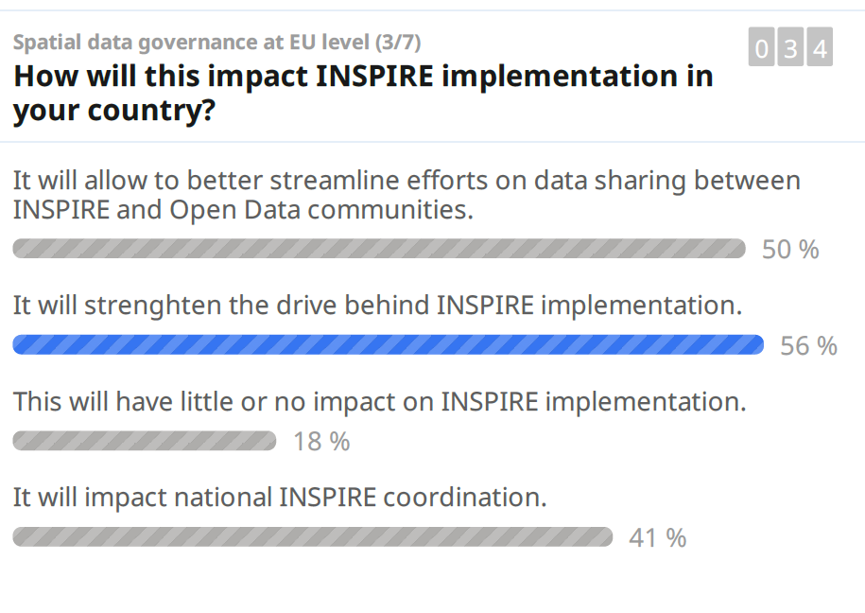

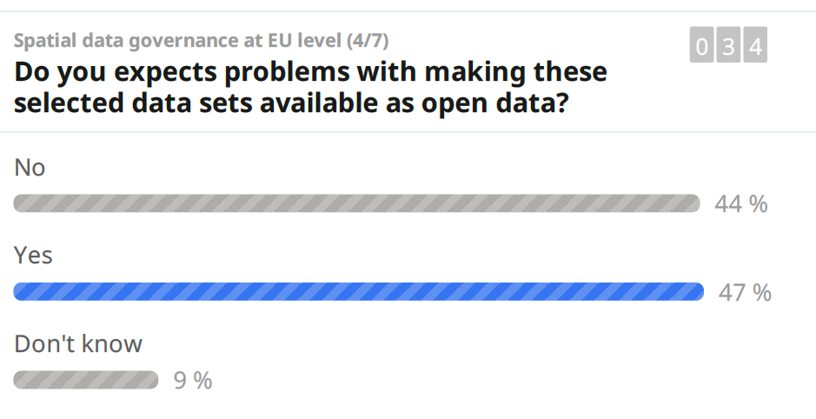

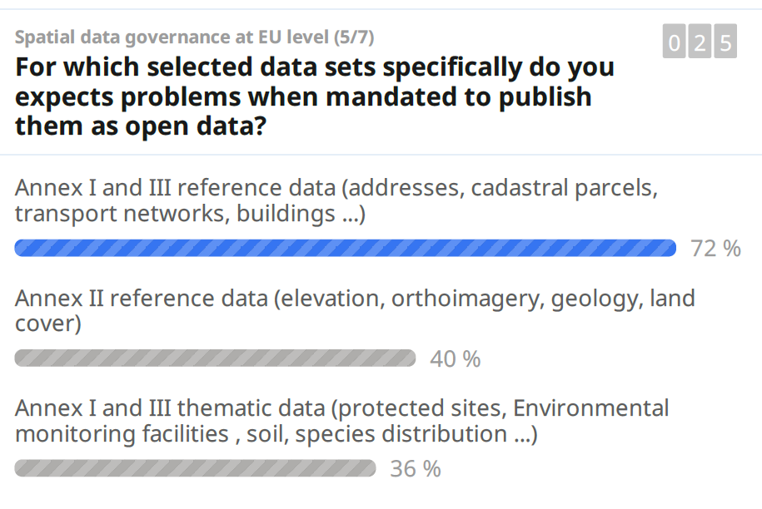

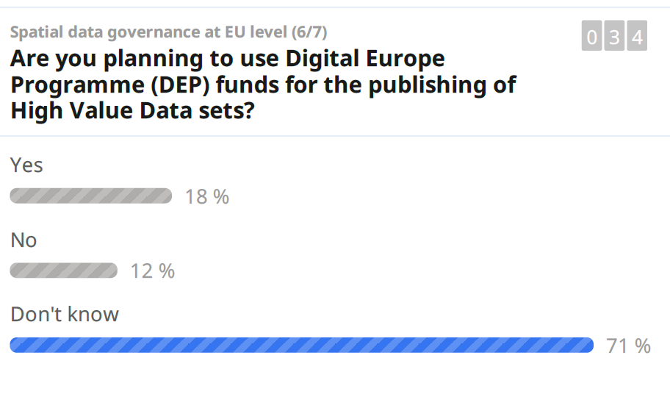

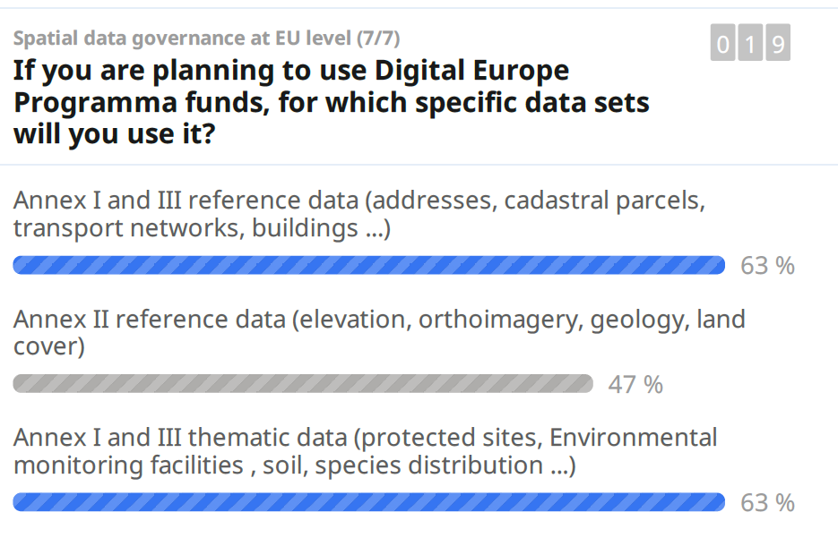

1. <https://webgate.ec.europa.eu/fpfis/wikis/x/1oaGIw>
2. <https://ec.europa.eu/jrc/en/publication/establishing-new-baseline-monitoring-status-eu-spatial-data-infrastructure>
3. <https://github.com/INSPIRE-MIF/>
4. <https://github.com/INSPIRE-MIF/gp-ogc-sensorthings-api>
5. <https://webgate.ec.europa.eu/fpfis/wikis/display/InspireMIG/Action+2016.5%3A+Priority+list+of+datasets+for+e-Reporting>
6. <https://inspire.ec.europa.eu/events/inspire-community-forum-webinar>
7. <https://youtu.be/qzkej232ItQ>
8. <https://webgate.ec.europa.eu/fpfis/wikis/x/1oaGIw>