**INSPIRE**

**Infrastructure for Spatial Information in Europe**

MIWP 2018.1: Monitoring and reporting 2019

|  |  |
| --- | --- |
| **Type** | Information document |
| **Creator** | EC and EEA INSPIRE Team |
| **Date/status/version** | 08/11/2018 |
| **Addressee** | MIG (for information) |
| **Identifier** | **MIG/8/2018/DOC8** |
| Description | This document informs the MIG about the status of action 2018.1 to develop a new, streamlined monitoring and reporting process in line with the review of the INSPIRE reporting decision. |
| **Requested actions:** | The members of the MIG are invited to:   * Take note of the document and discuss it at the 9th meeting of the MIG; |

# 2019 Reporting cycle

In view of possible changes to the existing legal monitoring and reporting provisions resulting from ongoing reviews (alignment proposal, review of reporting decision), 2019 will be is regarded as a transitional year for monitoring and reporting. Preparations for the monitoring and reporting exercise have to be currently based on the existing legal provisions but the new rules may enter into effect just before the 15 May 2019. Also it is in the Commission’s interest to pass on any reduction of administrative burden to the Member States as quickly as possible whilst at the same time providing clarity and certainty for all reporters. Hence, the following practical arrangements are proposed:

* The Commission services (JRC) will aim at installing a new reporting infrastructure and process that maximally reuse already existing INSPIRE components (discovery service, metadata, support, validation tools …) as quickly as possible.
* At the same time, the current monitoring system at the EEA will remain operational until the transition has been completed by all Member States.
* The Commission services and the EEA will support Member States during the transition to make sure that they can meet there legal obligations. Any issues arising during the transition will be handled in a pragmatic and solution-oriented way.
* Whilst the Commission cannot alter the monitoring and reporting obligations only for this year of transition, Member States are invited to inform the Commission before the 15 May if there are any likely issues or delays as a result of the transition. Should such issue arise, they will be dealt with on a case-by-case basis bilaterally.

The Commission services and the EEA trust that this approach will help organise the transition in the most effective and efficient way resulting in a benefit thereafter for all parties involved.

# 2018.1 Status

## 2018.1 Subgroup

The kick-off meeting for the subgroup 2018.1 is scheduled for 04 and 05 December at the JRC offices in Ispra (IT). 12 participants confirmed to attend the meeting (mostly member of previous 2016.2 monitoring and reporting subgroup). The meeting will focus on the outcome of the vote on the adoption of the new Regulation for monitoring and reporting, user requirements, workflow, planning and development of the system.

## INSPIRE M&R System

### CONTEXT AND BACKGROUND INFORMATION

The previous MIG subgroup 2016.2 carried out activities to simplify and streamline monitoring and reporting under the INSPIRE Directive. The outcomes of their work were the 2016 INSPIRE country fiches (<http://inspire.ec.europa.eu/INSPIRE-in-your-Country>) and the draft proposal for new INSPIRE Reporting Decision. The proposal for a new Reporting Decision was endorsed by MIG and received a positive opinion by the INSPIRE Committee in June 2018.

The current system of monitoring is based on data provided by MS through envelopes in EEA Reportnet (<http://rod.eionet.europa.eu/obligations/692>). The indicators are calculated based on the data provided and displayed through INSPIRE Dashboard (<https://inspire-dashboard.eea.europa.eu/#/>). Reporting is based on three years reports provided by MS also through envelope in EEA Reportnet (<http://rod.eionet.europa.eu/obligations/614>). It is usually a PDF or DOC file with a reporting structure accordingly to an agreed template. Reports provided by MS in 2016 were used as input for development of country fiches.

### PURPOSE, OBJECTIVES AND SCOPE

The purpose of this work is to develop a new monitoring and reporting system in accordance with new Reporting Decision. The new monitoring and reporting system should be based on the monitoring indicators that are calculated automatically from the metadata. The reporting part should be based on the online system of the country fiches, which include as an integral part a dashboard with graphical and numerical visualization of calculated indicators.

The workflow in the new system is shown on figure 1.

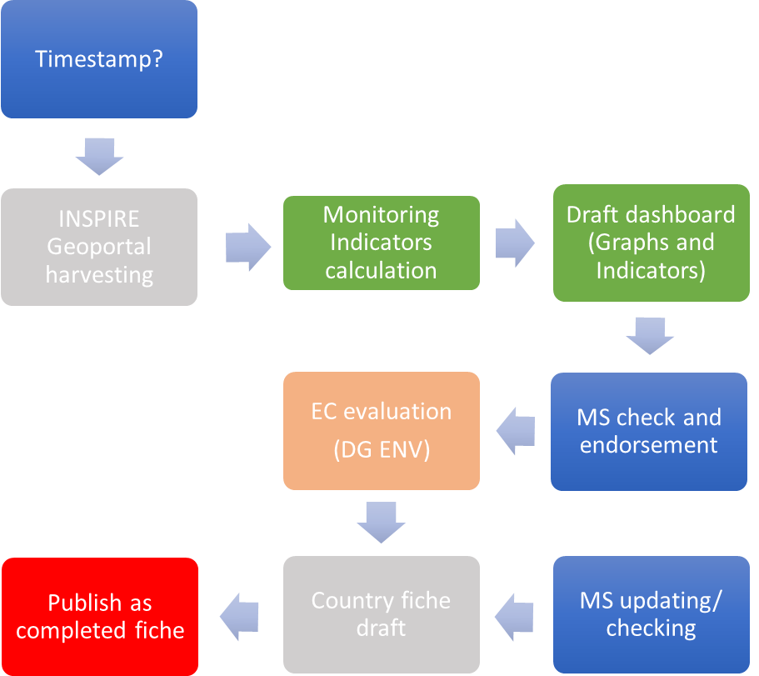

Figure 1. Monitoring and Reporting workflow

Users of the system and their needs:

* MS reporters. Should be able to enter/update the parts in the country fiche for which they are responsible. They can also view draft dashboard and check it. Based on it they can endorse draft dashboard or ask/claim for changes/updates. They can also view and check the draft country fiche before publishing.
* DG JRC. Responsible for the whole system and specifically for harvesting and calculation of indicators. Preparation of draft dashboard and country fiche.
* DG ENV. Responsible for evaluation and providing of specific recommendations. Should be able to enter/update the relevant parts in the country fiche.
* EEA (Reportnet 3.0). Responsible for publishing and updating annually the EU wide overview.
* Users (citizens). To access and browse country fiches.

### WORKING APPROACH AND METHODOLOGY

The development of the new system will be based on the Thematic Viewer as a new front end of INSPIRE geoportal. The proposed architecture of the system is shown at figure 2.

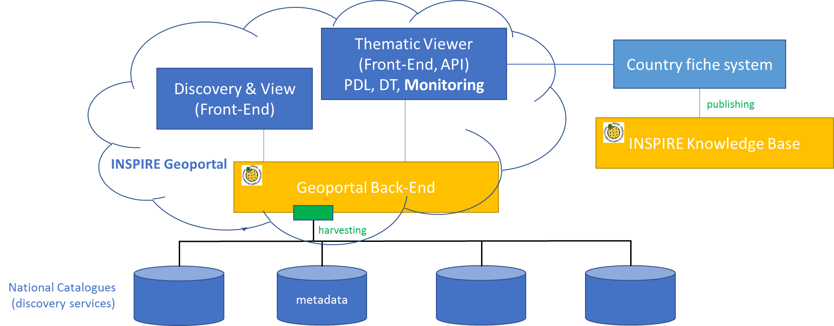

Figure 2. INSPIRE M&R Architecture overview

Annex 1: Mandate for MIWP action 2018.1

MIWP 2018.1: Streamlining the monitoring and reporting for 2019

|  |  |  |  |  |  |
| --- | --- | --- | --- | --- | --- |
| **Title** | **Streamlining the monitoring and reporting for 2019** | | | | |
| **ID** | 2018.1 | | | | |
| **Status** | Proposed | Endorsed | | In Progress | Completed |
| **Issue** | The previous MIG subgroup 2016.2 carried out activities to simplify and streamline monitoring and reporting under the INSPIRE Directive. The findings of the subgroup were used to develop the 2016 INSPIRE country fiches (<http://inspire.ec.europa.eu/INSPIRE-in-your-Country>) and the draft proposal for a new INSPIRE Reporting Decision.  The new INSPIRE Reporting Decision will rely on the reuse of metadata for the monitoring of the implementation of the INSPIRE Directive in the Member States. To support this a new monitoring and reporting system should be developed that supports automated calculation of indicators out of the metadata and provides an online system for management and maintenance of country fiches . | | | | |
| **Proposed action** | * Development of a new, streamlined monitoring and reporting process; * Conceptual design of the new monitoring and reporting system; * Prototyping, testing and implementation of the new monitoring and reporting system and process. * Data migration from the current dashboard system hosted at EEA | | | | |
| **Links & dependencies** | Dependencies:   * Adoption of the new INSPIRE Reporting Decision * Adoption of the alignment proposal for environmental reporting * Online Country fiche system * Reportnet 3.0 development   Links:   * The activity of subgroup 2016.5 Priority list of data sets for eReporting. | | | | |
| **Organisational set-up** | The action is carried out by the JRC, with support from a temporary MIG sub-group, which will act as a steering group for the development of the new reporting process and system and will be involved in testing prototypes and release candidates. It is proposed to reactivate the previously closed sub-group 2016.2 on “Monitoring & Reporting 2019”  EEA should be closely involved, specifically for the transfer of reporting knowledge, the migration of legacy monitoring data and as lead for action 2016.5 on the priority data sets. | | | | |
| **Lead** | JRC (in collaboration with DG ENV and EEA) | | | | |
| **Scope** | Design and development of new monitoring and reporting system based on country fiches and automatic calculation of monitoring indicators from metadata.  Any IT developments done should be usable by MS at MS level for MS needs and by the EC at European level for EC needs.  The new monitoring and reporting system should provide an API, so that it can be used by or integrated into other applications, including ReportNet 3.0. | | | | |
| **Tasks** | * Design and Implementation [2018]   + Delivery of technical proposals to support the updated MR decision   + Prototype / agile development of new monitoring and reporting system, including editing content and visualization of the calculated indicators in online country fiches   + Transition of legacy data from EEA systems   + Guidelines (user documentation)   + Testing and improvement of the new system   + System in production by 10 December 2018 * Operating and maintaining the new system in production [2019 - ….] | | | | |
| **Outcomes** | * New system for monitoring and reporting (Country fiche system with integrated dashboard for visualization of indicators) * User documentation for use of the system and reporting process | | | | |
| **Proposed Impact** | Technical Adjustment / Bug Fixing  Technical Improvement / Development  Practical Support for Implementing Process  Cost Reducing Effect for Implementing Process  Direct Support on Policy-Making / - Activities | | | | |
| **Timeline** | Date of Kick-off: July 2018 | | | | |
| Proposed Date of Completion: 31/05/2019 | | | | |
| **Required human resources and expertise** | MIG-P, MIG-T and INSPIRE rapporteurs with experience of at least one monitoring and one reporting exercise. | | | | |
| **Required financial resources and possible funding** | Funding by DG ENV through the Administrative Arrangement with the JRC.  Additional resources should be put aside for a minimum of 2 physical workshops. | | | | |
| **Risk factors** | Overall risk level of the action  High  Medium  Low | | Risk factors to be considered  Missing Resources  High Complexity  Interdependencies with other Actions  Others:   * No adoption of a new Reporting Decision * No adoption of the alignment proposal for environmental reporting | | |