**Description: ESECINSPIRE   
Maintenance and Implementation Group (MIG)**

**Update on Commission initiatives**

|  |  |
| --- | --- |
| **Type** | Draft Information document |
| **Creator** | DG ENV |
| **Date / status** | 07/11/2018 – DRAFT |
| **Addressee** | INSPIRE Maintenance and Implementation Group |
| **Identifier** | **MIG/9/2018/DOC3** |
| Description | Update on Commission initiatives.  **MIG members are invited to take note of this information and to share it with relevant colleagues and communities, as appropriate.** |

Contents

1. Reporting Fitness Check: outcome and next steps, relevance for INSPIRE (Action 6) and alignment proposal (Action 1) (ENV) 2

1.1. Alignment Proposal 2

1.2. INSPIRE & streamlined e-Reporting 2

1.2.1. Invasive Alien Species 2

1.2.2. MSFD 3

1.2.3. EU Registry on Industrial Sites 3

1.2.4. Floods Directive 4

1.2.5. Environmental Noise Directive 5

2. Study on improving national environmental information and data harvesting (FC Action Plan actions 4 and 5) (ENV) 5

3. Study of INSPIRE data sharing, access and use (Art. 17 and related provisions) (ENV) 6

4. Copernicus – latest developments (ENV) 6

5. INSPIRE Conference 2018 (ALL) 6

6. Reportnet 3.0 15

# Reporting Fitness Check: outcome and next steps, relevance for INSPIRE (Action 6) and alignment proposal (Action 1) (ENV)

## Alignment Proposal

A [Proposal](http://ec.europa.eu/environment/legal/reporting/pdf/1_EN_ACT_part1.pdf) for a Regulation on the alignment of reporting obligations in the field of environment policy was adopted on 31 May 2018. The proposal implements action 1 of the Fitness Check evaluation [action plan](http://ec.europa.eu/environment/legal/reporting/pdf/action_plan_env_issues.pdf). This alignment proposal has been prepared on the basis of the evidence in the Fitness Check evaluation and other evaluations that were recently carried out on individual pieces of legislation. The alignment proposal’s objectives are to improve the evidence base for implementing EU policy, increase transparency for the public and simplify reporting with a view to reducing administrative burden. It covers 10 pieces of environmental legislation, namely Directives 86/278/EEC, 2002/49/EC, 2004/35/EC, 2007/2/EC, 2009/147/EC and 2010/63/EU, Regulations (EC) No 166/2006 and (EU) No 995/2010, and Council Regulations (EC) No 338/97 and (EC) No 2173/2005. For several pieces of legislation the reference to the use of INSPIRE in the monitoring and reporting process was introduced. In addition, changes are proposed to the INSPIRE Directive related to monitoring and reporting are proposed.

Currently negotiations are ongoing between European Parliament, European Council and European Commission to discuss any remaining issues. It is expected that a consensus will be reached by the end of the year.

## INSPIRE & streamlined e-Reporting

### Invasive Alien Species

Geospatial data on the invasive alien species (IAS) distribution, associated observations and metadata shall be delivered in line with INSPIRE. Commission Implementing Regulation (EU) 2017/1454 specifies the technical formats for reporting by the Member States. A reporting workflow has been developed in response, where data on IAS will be made available to MS from the JRC European Alien Species Information Network (EASIN) database. The EASIN collects and indexes spatial data on the distribution of the Alien Species in Europe from a network of Data Partners.

The JRC is finalising Guidelines for the compilation of reports on Species Distribution (SD) of Invasive Alien Species of Union concern. They will be presented and discussed on 14 November during the 1st meeting of the Invasive Alien Species Expert Group (IASEG). A pre-meeting is planned for the afternoon of 13 November, with updates from JRC, EEA/ETC, contractors (EaudeWeb & WUR) and ENV. Also the organisation of the meeting on 14 November with the Member States will be discussed and coordinated.

Data made available to MS will be encoded in accordance with an extended INSPIRE Species Distribution (SD) Data Model. Observations, distribution data and metadata will be bundled together. MS will update and push their national data to a dedicated EEA repository.

### MSFD

The EC&EEA INSPIRE team is providing regular support to TG DATA of the MSFD in complying with the requirements of Art. 19 of the Directive. Detailed technical guidance covering all aspects related to the creation of metadata, data harmonisation and network services have been compiled by the EEA. Several use cases with heterogeneous data encoded in accordance with INSPIRE are also available. The possibility for harvesting the catalogues of regional sea conventions and the consequent reuse of the metadata are being investigated.

In parallel, in collaboration with DG MARE, the implementation of INSPIRE by EMODnet portals is discussed. A dedicated wiki page is created, where EMODnet portals share requirements for data harmonisation and outstanding technical issues.

### EU Registry on Industrial Sites

The **EU Registry on Industrial Sites[1]** is a data flow that collects information on the facilities, installations, and plants, which EU countries (as well as EFTA countries and Serbia) are obliged to report under the **European Pollutant Release and Transfer Register (E-PRTR) Regulation** and the **Industrial Emissions Directive (IED)**. The EU Registry will be the reference dataset to which relevant thematic reporting on Large Combustion Plants (LCPs) and other industrial facilities falling under the abovemention legislation will link to (i.e. data on releases and transfers referring to the entities reported to the EU Registry). The most relevant aspect here is that the **EU Registry will contain all relevant permit and geospatial information** of these industrial entities, avoiding its duplication in the thematic data flows. This shall reduce reporting burden and data management costs, ensuring further investments by reporting countries are not required in the medium term to comply with INSPIRE.

While avoiding inconsistencies across the sectorial legislation, the EU Registry data model[2] extends the INSPIRE **Production and Industrial Facilities** (PF) core model[3] in accordance to the rules set out in the INSPIRE Generic Conceptual Model. During the modelling exercise, it became clear that the INSPIRE PF model was very comprehensive and catered for a very high level of detail, with a number of fields and some feature types which were identified as not relevant in the EU Registry context. Therefore, a streamlined view has been developed, including the feature types and fields relevant to the EU registry reporting, with all mandatory and non-voidable elements, as well as domain reporting requirements and a series of modifications which have no impact on the INSPIRE compliance of the reported data by countries. The rationale for this choice is based on the assumption that Member States do not collect or make available further data on this subject. The modified schemas of the INSPIRE PF model and the INSPIRE Activity Complex (which is imported by the former) are stored locally in the Reportnet Data Dictionary[4], facilitating the workflow and the schema validation process. It is important to stress that all implemented changes do not break INSPIRE rules, since they operate on INSPIRE-allowed values (restrictions on the relevant element domain).

At the same time, **the thematic data (e.g. emissions)** which collection is required by the IED and the E-PRTR have been also subject to a streamlining exercise and an integrated data model[5] has been designed in order to operate in parallel with the EU Registry data flow. The thematic data model under both legislative instruments only concerns the transmission of emissions and associated activity data for industrial emissions entities that are included in the EU Registry. The link between these two reporting data flows is based on a consistent use of identifiers between related feature types. In particular, **the INSPIRE identifiers (*inspireId*) of the relevant features will be the key attribute that ties these entities (and therefore their geospatial information) to the corresponding emission data**. The implementation of this relation eliminates the need to provide geospatial information or identification (administrative) data in each thematic data flow.

QA/QC procedures ensure that, when combined, data submitted via both data flows remain logic and coherent to the requirements of the industrial legislation. The EEA will then harvest all country data submission and aggregate them in a European-wide multi-year data set of industrial sites that can be used for analysis, publication and support of environmental programmes.

The EU Registry on Industrial Sites, which model was finalised and published in August 2018, is to be launched operationally during the first quarter of 2019, with the deadline for the first reporting (ref. year 2017) being June 2019. It is expected that the first pan European dataset based on the EU Registry will be available by the end of 2019. The thematic data model has been developed in 2018 and the first reporting deadline will be in 2020.

### Floods Directive

In the subgroup of the Workgroup on the **Floods Directive** on the updating of reporting tools it was proposed and agreed to use:

* the INSPIRE “Management Restriction Or Regulation Zone” to model the units of management;
* the INSPIRE “Risk Zone” (subtype of AbstractRiskZone) for the Areas with Potential Significant Flood Risk (APSFR);
* the INSPIRE “Hazard Area” (subtype of AbstractHazardArea) for modeling the Preliminary Flood Risk Assessment (PFRA).

The work on the model was finalised in the subgroup meeting of 23 October 2018. Since a considerable amount of Member States indicated that they prefer to use shapefiles for reporting spatial data, the reporting model will support a flat structure. For the modelling of the Areas of Potential Significant Flood Risk (APSFR) an extension to the relevant INSPIRE data specification is needed.

### Environmental Noise Directive

In the last NOISE REGULATORY COMMITTEE (25/09/2018) the progress on INSPIRE implementation for the priority eReporting use case in general and the NOISE Directive specifically was presented. An update of the high-level streamlining roadmap and future actions was presented and discussed:

**Future Actions**

* Q3/18 – Q3/19: develop common reporting model and process aligned with Reportnet 3.0; address implementation gaps.
* Q4/19 – Q4/20: common reporting model and process implementation by Member States (INSPIRE interoperability deadline in 2020)
* 2021: Test e-reporting model & process (MS/EEA/ENV)
* 2022: next NOISE reporting cycle - NOISE reporting and INSPIRE obligations aligned

# Study on improving national environmental information and data harvesting (FC Action Plan actions 4 and 5) (ENV)

This project implements actions 4 and 5 of the Reporting Fitness Check Action Plan and is entering its decisive phase.

The recent interviews to establish user needs were very helpful and we use this opportunity to thank colleagues and participants to the workshop for their input. In addition, the project is making progress on the development of the guidance and the assessment of the national information systems is being finalised.

The next Workshop with Member States will take place on 11 and 12 December 2018 at the JRC in Ispra (IT). A first draft of the guidelines, initial demonstrators and a roadmap for further development will be delivered in the quarter of 2019.

# Study of INSPIRE data sharing, access and use (Art. 17 and related provisions) (ENV)

To be completed.

# Copernicus – latest developments (ENV)

To be completed.

# INSPIRE Conference 2018 (ALL)

The INSPIRE Conference 2016 “INSPIRE Users – Make it work together’ was co-organised together with Belgium and The Netherlands. It took place from 18-21 September 2018 in Antwerp. The conference was attended by over 750 participants from all levels of public administrations in the MS/EEA:EFTA and CAC, few outside Europe, the private sector, universities, European and International Organisations, several Commission Services (DG ENV, CNECT, ENER, MOVE, DIGIT, ESTAT, GROW, REGIO, RTD and AGRI) and the EEA

In line with the scoping priorities presented in the [This Conference](https://inspire.ec.europa.eu/conference2018/thisconference) section we had 3 strands for the conference:

[1. Inspire the Users](http://inspire.ec.europa.eu/conference2018/call-for-submissions#menu1)

[2. Doing it Together](http://inspire.ec.europa.eu/conference2018/call-for-submissions#menu2)

[3. Making it Work](http://inspire.ec.europa.eu/conference2018/call-for-submissions#menu3)

It was organised with 4 plenary sessions, 44 parallel sessions, 20 workshops training sessions, commercial presentations, technical exhibitions and side events.

In the **opening plenary** chaired by DG ENV Director Aurel Ciobanu-Dordea, the BE Federal Minister Steven Vandeput, emphasised the importance of INSPIRE for a wide range of policies, environmental and beyond. Max Strottman of the VP Ansip cabinet, delivered a speech on the digital transition of society, highlighting several issues addressed by the Digital Single Market (DSM) initiative. He emphasised the importance of spatial information and the INSPIRE Directive as an enabler in line with the EU DSM and Interoperability Framework and Strategy, EIF/EIS and it’s importance in the context of the proposed recast of Re-use of Public Information, PSI directive . Other keynotes illustrated its international, global relevance in the context of the SDG’s and the importance to act on local issues to protect the environment, making use of historical and monitoring spatial information. DG ENV Director Aurel Ciobanu-Dordea introduced the conference scope and its focus on applications and collaboration at both governmental and technical level. He noted the increased use and references to INSPIRE in current and future EU legislation and initiatives. He emphasised the need for INSPIRE to deliver as the expectations are rising.

|  |  |  |
| --- | --- | --- |
| [Watch Plenary Video](https://youtu.be/poEPl5eAwzQ) | | |
| Maximilian Strotmann | [Member of Cabinet, Vice-President Andrus Ansip, European Commission](https://ec.europa.eu/commission/commissioners/2014-2019/ansip_en) |  |
| Aurel Ciobanu-Dordea | [Director in the Directorate-General Environment, European Commission](http://ec.europa.eu/dgs/environment/index_en.htm) |  |
| Piero Bruni | [President of the Associazione Lago di Bolsena](http://www.bolsenalagodeuropa.net/en/piero_bruni/) | PDF icon[View Presentation](https://inspire.ec.europa.eu/sites/default/files/presentations/pdfen-piero_bruni_presentazione_inspire.pdf) |
| Mrs. Dorine Burmanje | [CEO Netherlands' Cadastre, Land Registry and Mapping Agency](https://www.kadaster.com/) | PDF icon[View Presentation](https://inspire.ec.europa.eu/sites/default/files/presentations/pdfen-slides_dorine_burmanje.pdf) |
| Steven Vandeput | [Minister of Defence of Belgium](http://www.vandeput.fgov.be/en) |  |

The **plenary on “The transition to a Green Economy and INSPIRE”** was chaired and moderated by Hans Bruyninckx, [Executive Director of the European Environment Agency](https://inspire.ec.europa.eu/).

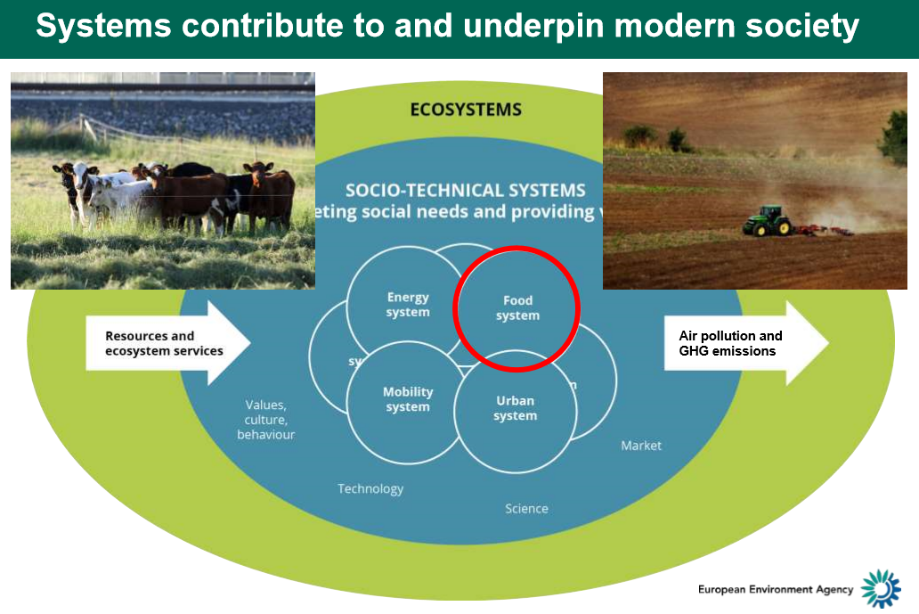

He illustrated the importance of spatial information from an ecosystem perspective, underpinned by food - , energy - , urban - and mobility socio-technical systems. Several examples were given on air quality, urban sprawl, near-real time monitoring etc.

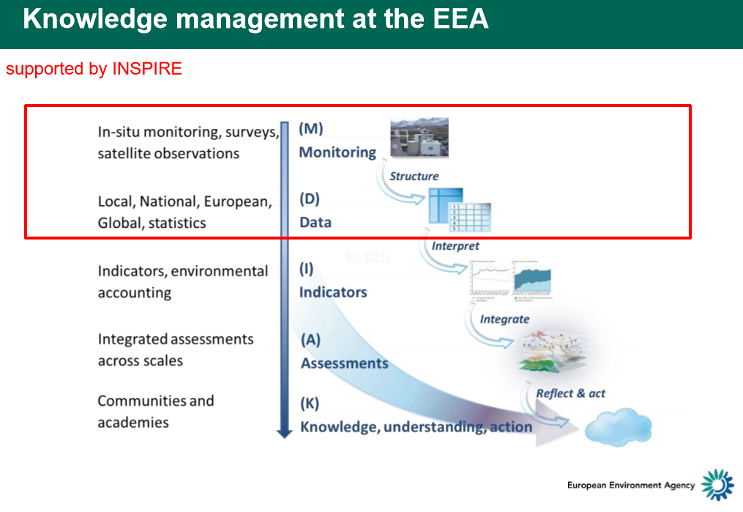

He positioned INSPIRE as an infrastructure which potentially underpins core ‘Knowledge management’ EEA tasks for which monitoring data is required

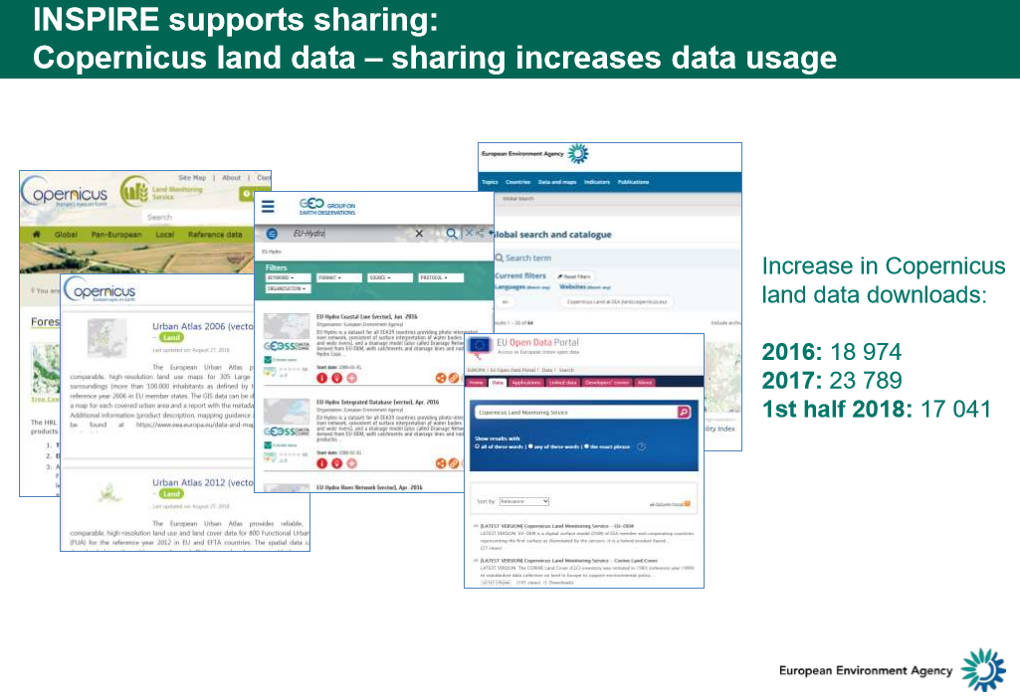He emphasized the ‘sharing’ of EEA and EEA Copernicus Land service data conform to the INSPIRE principles and technical specifications. Illustrated by an exponential growth in downloads since these services are in place.

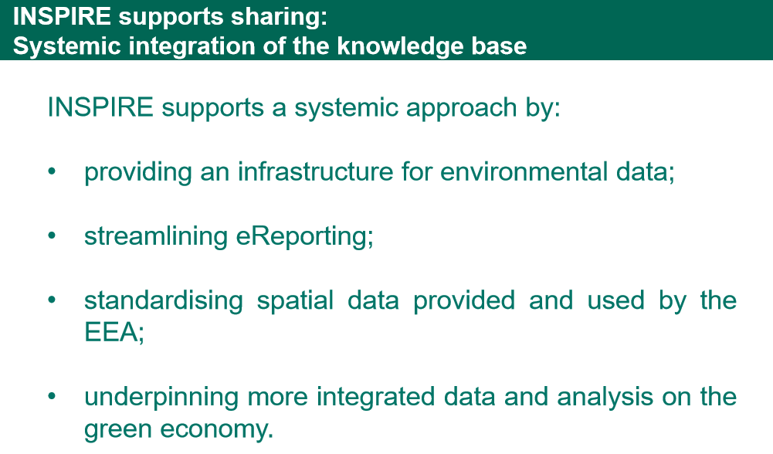

This scene setting by the EEA was followed by presentations from the agricultural, energy and waste socio-economic sectors.

The director of a small Dutch SME presented the ‘[Value of Geospatial Data in the Agricultural Sector’](https://inspire.ec.europa.eu/sites/default/files/presentations/pdfen-4_jannekehaddersdacom_-_nspire_19_september_2018.pdf). The talk was an excellent showcase on the use of GEOINT for sustainable agriculture. It also showed the importance of an efficient national INSPIRE implementation in The Netherlands providing a wide range of spatial government data relevant for the agricultural domain applications.

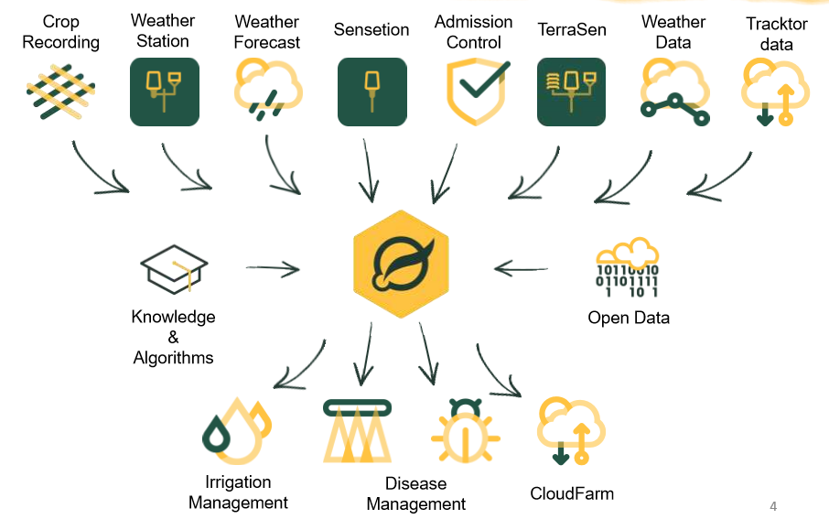

This also included the link to Copernicus, with derived information integrated in an application used by farmers.

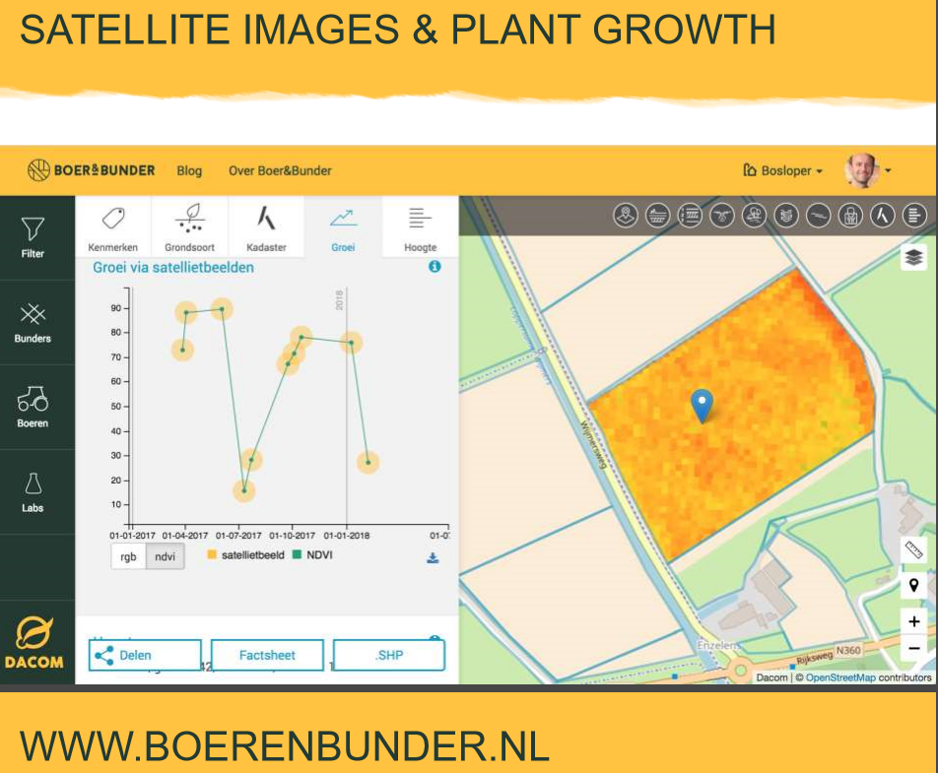

This [application](https://boerenbunder.nl/filter/) is a direct support to farmers – and very relevant for the Environmental Compliance Assurance Action Plan – support to duty holders in rural areas.

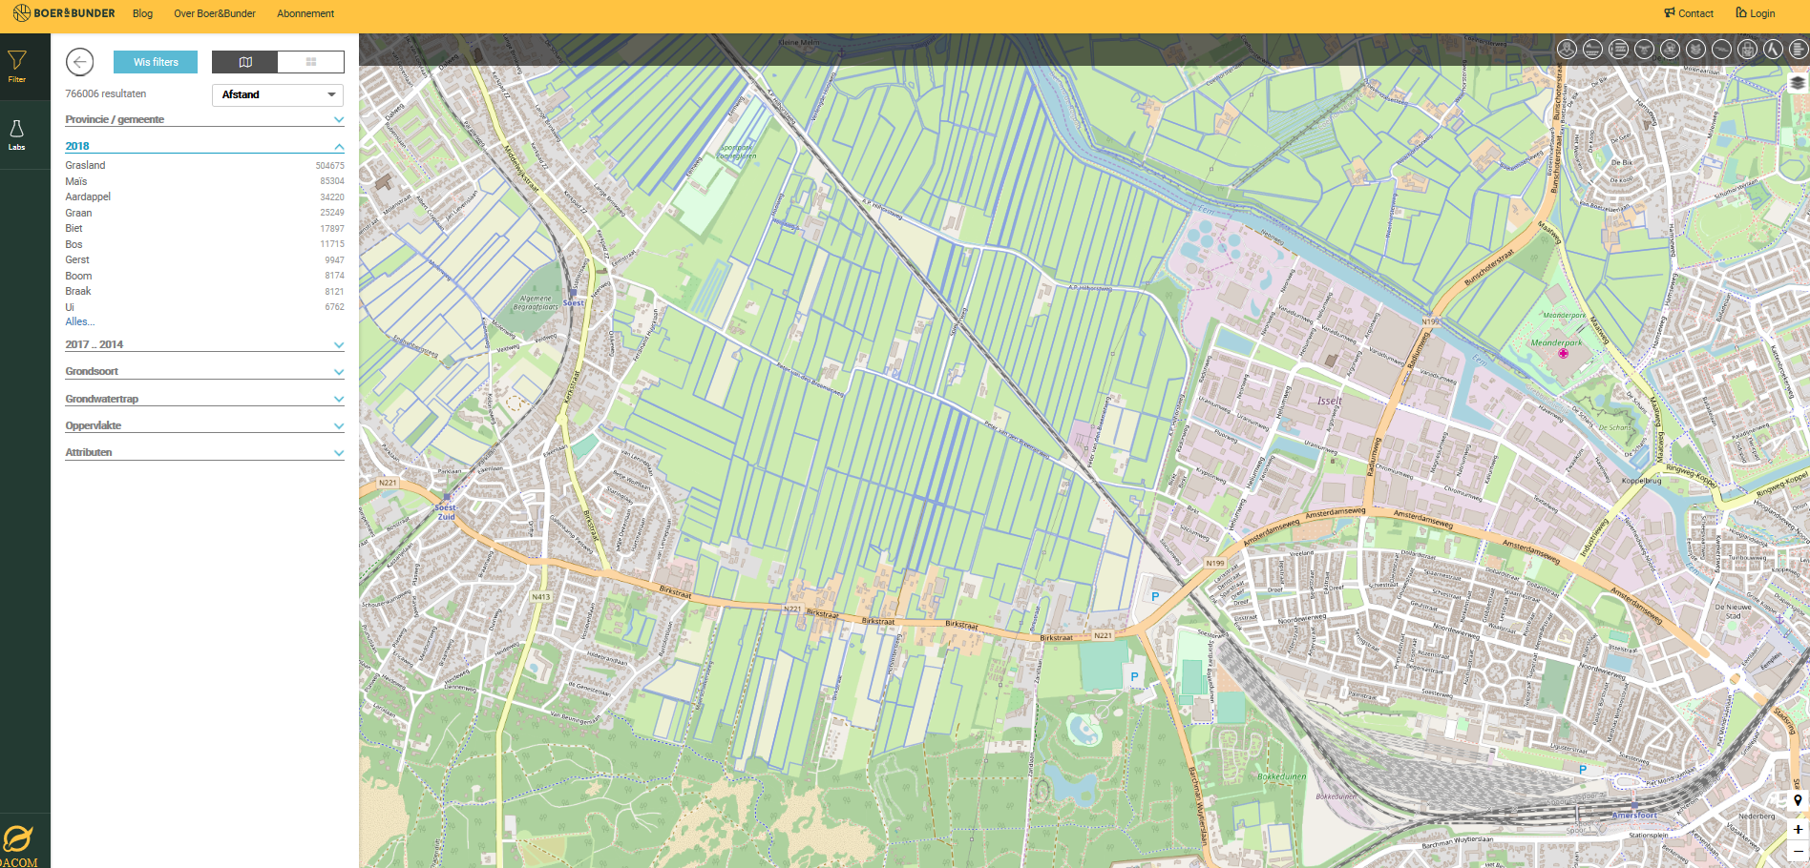



There was a big ‘thumbs-up’ for INSPIRE and a strong call to ensure that also in other Member States INSPIRE would become implemented to allow for such applications. Currently, this not seems to be the case.

The [presentation on ‘Energy –Space and Time’](https://inspire.ec.europa.eu/sites/default/files/presentations/pdfen-3_arashaazami20180919_inspire_ioe.pdf) was less focused directly on INSPIRE, yet it provided a highly interesting insight in the past, current and future energy related societal challenges.

It presented the structural transition of energy supply, distribution and consumption over time – from centralized to an ‘internet of energy’.

|  |  |  |
| --- | --- | --- |
|  |  |  |

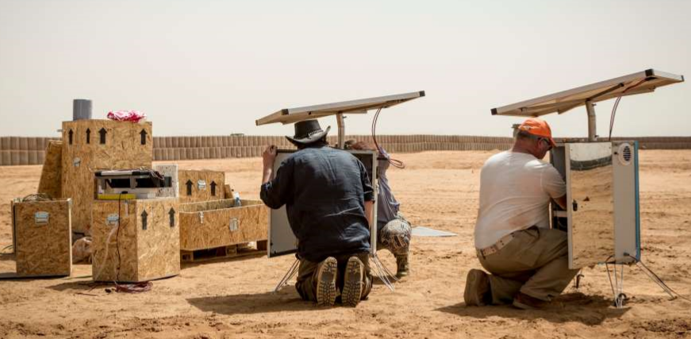

Implicitly, it showed the importance of INSPIRE as the geospatial framework containing information on energy production facilities and location (both renewable and non-renewable), the energy distribution facilities and consumption/production nodes (buildings, land areas & parcels equipped with their own energy production/management infrastructures).

The [presentation on waste](https://inspire.ec.europa.eu/sites/default/files/presentations/pdfen-2_2018.09_inspire_conference_5_final.pdf) focused on “The Water/Waste/Energy Cycle” from a business perspective. It presented the data ecosystem of a major industrial multi-national player, VEOLIA, with a clear message: ‘We are at the heart of the Green Economy… ... thanks to our digital capabilities”.

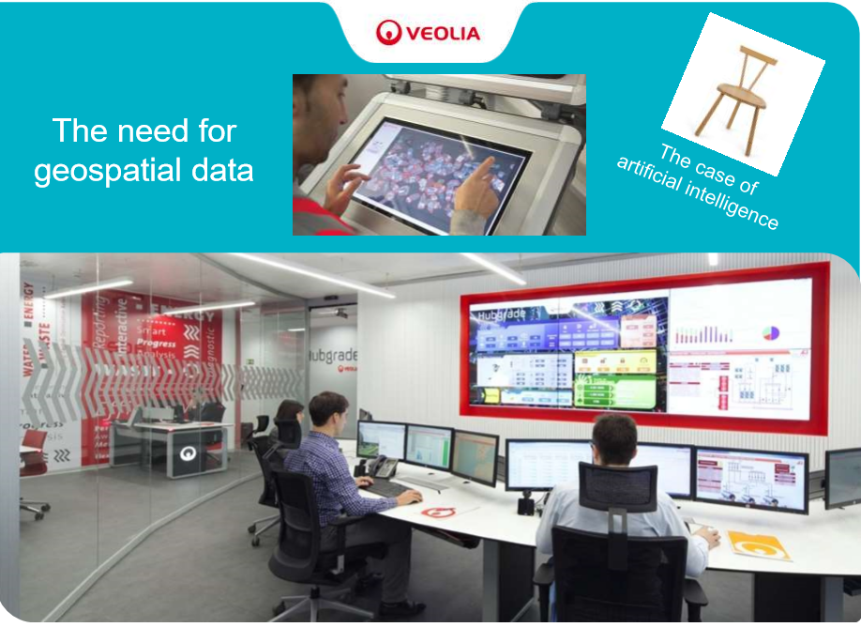It showed the need for geospatial data for innovation and the transformation of urban services in a smart city, smart citizens & connected technologies context.

There was strong call for “Access to data and transparency => more ambitious sectoral regulations” and for “Data ethics and data pragmatism => strike the right balance”. As such, it was another call for public-private-partnership to create an “optimal data ecosystem to solve our common challenges”.

The concluding panel discussion emphasized the importance of access to data as a source of innovation for greening the economy. From the conference floor came a few questions and remarks also on the current ‘inefficiency’ of INSPIRE in making this data available and on how also ‘private sector’ data could become part of the content accessible through this data infrastructure. The business models – free and open were discussed – as ‘not everything comes for free’. The relevancy of the decade ‘old’ INSPIRE ‘business’ model for the emerging needs is an issue that needs further reflection – perhaps, an evolutionary path, for a new “INSPIRE”.

|  |  |  |
| --- | --- | --- |
| [**Watch Plenary Video**](https://youtu.be/GLyBBJGewrM) | | |
| Hans Bruyninckx | [Executive Director of the European Environment Agency.](https://inspire.ec.europa.eu/) | PDF icon[View Presentation](https://inspire.ec.europa.eu/sites/default/files/presentations/pdfen-1_inspire_hans_bruyninckx_19092018.pdf) |
| Janneke Hadders | [Director of Dacom](https://dacom.farm/) | PDF icon[View Presentation](https://inspire.ec.europa.eu/sites/default/files/presentations/pdfen-4_jannekehaddersdacom_-_nspire_19_september_2018.pdf) |
| Arash Aazami | [Founder Universalright.org](http://www.universalright.org/) | PDF icon[View Presentation](https://inspire.ec.europa.eu/sites/default/files/presentations/pdfen-3_arashaazami20180919_inspire_ioe.pdf) |
| Claire Falzone | [CEO of Nova Veolia](https://nova.veolia.com/) | PDF icon[View Presentation](https://inspire.ec.europa.eu/sites/default/files/presentations/pdfen-2_2018.09_inspire_conference_5_final.pdf) |

The **plenary on “Digital Transformation – INSPIRE – Digital Transition”** was chaired and moderated by Alessandro Annoni, Head of the Digital Economy Unit, JRC. The key note presentations were delivered by a major international player in the navigation/mobility domain, TomTom. The major geospatial data and service international standards development organisation, OGC, a representative of major EU e-Government/Smart cities initiative on a [‘partnership of the Urban Agenda’](https://ec.europa.eu/futurium/en/urban-agenda) (relevant for cohesion, digital and environment policies) and an international speaker, and SME entrepreneur from the Caribbean region.

The presentation of TomTom, focused on the ‘Big Data Revolution’. It emphazised the importance of ‘Open data’ for integration with the real-time massive data streams for navigation and other mobile devices and sensors to develop for example better and safer navigation systems for autonomous driving vehicles.

The presentation form the OGC Innovation programme focused on the importance of INSPIRE in the context of Smart Cities and the Digital Transformation. It illustrated the wide impact of INSPIRE in major EU initiatives such as the European Innovation Partnership, IEP for Smart Cities.

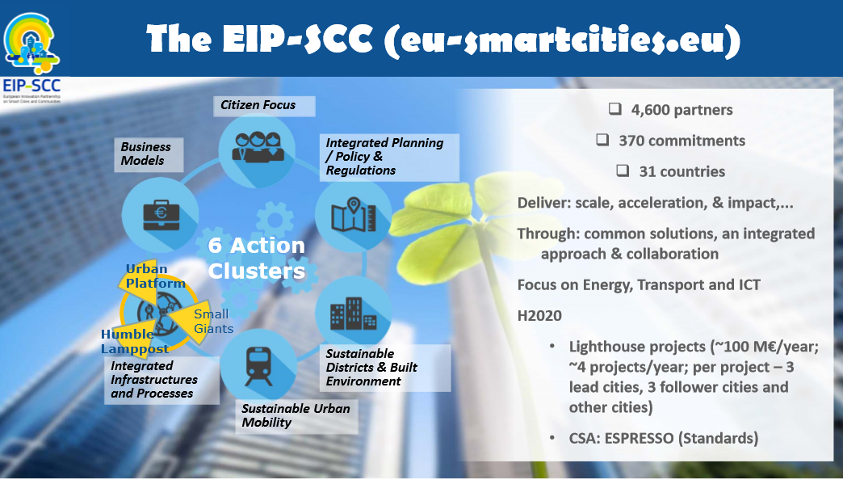

Both the ‘Big data’ and the ‘Smart Cities’ key notes illustrated the broad application field of INSPIRE and need to move towards a spatial data infrastructure that can cater for the more static types of government INSPIRE data as well as the private real-time sensor data collected. **There was a strong call to further break down the data silos which INSPIRE from its onset tried intended to address**.



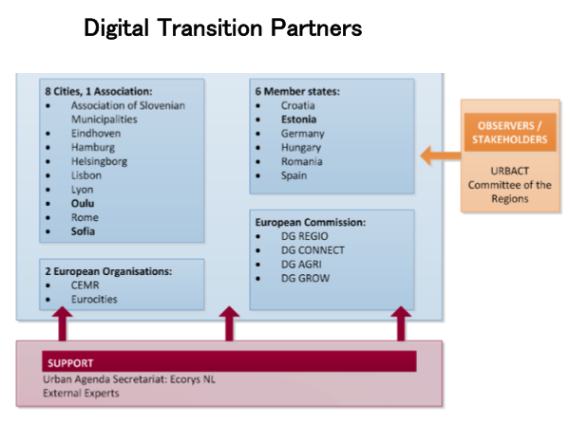

The presentation on the ‘Urban Agenda’ showed the wide policy interest.

The Action Plan of the Urban Partnership, Action 8, contains a direct reference to INSPIRE for the ‘Specification and monitoring of standardised planned land use (PLU) data for formal and informal urban planning participation processes’.

Hence, illustrating the importance of INSPIRE as a ‘technical framework’ for the more efficient sharing and use of spatial data for land use planning.

|  |  |  |
| --- | --- | --- |
| [**Watch Plenary Video**](https://youtu.be/SuWvfjzJYME) | | |
| Ms Valrie Grant | [Managing Director of GeoTechVision](http://valriegrant.com/) | PDF icon[View Presentation](https://inspire.ec.europa.eu/sites/default/files/presentations/4_valrie_grant_digitaltransformation_180918.pdf) |
| Alessandro Annoni | [Head of the Digital Economy Unit, JRC](https://ec.europa.eu/jrc/en) |  |
| Bart De Lathouwer | [Director, Innovation Program OGC](http://www.opengeospatial.org/) | PDF icon[View Presentation](https://inspire.ec.europa.eu/sites/default/files/presentations/2_bart_de_lathouwer_ogc_plenary_20sep18.pdf) |
| Alain De Taeye | [TomTom Management Board Member](http://corporate.tomtom.com/management.cfm) | PDF icon[View Presentation](https://inspire.ec.europa.eu/sites/default/files/presentations/1_alain_de_taeye_final.pdf) |
| Celine Berggreen-Clausen | [Project manager for the City of Helsingborg](https://helsingborg.se/) | PDF icon[View Presentation](https://inspire.ec.europa.eu/sites/default/files/presentations/33_celine_berggreen_inspire_celinebc_ver2.pdf) |

the partnership of the Urban Agenda

The **Closing plenary** presented a wrap-up the conference and a most interesting citizens science project – relevant for the Environmental Knowledge Community, EKC action on Citizens Science in the domain of air quality as well as for the Environmental Compliance Assurance Action Plan, Action on GEOINT.

In 2019 there will be no INSPIRE conference. Yet, in the first semester of 2020, Croatia, which have the presidency of the EU, announced its intend to organise with the EC the conference in Dubrovnic.

|  |  |  |
| --- | --- | --- |
| [**Watch Plenary Video**](https://youtu.be/-do75bw_Py0) | | |
| Rob van de Velde | [Director Geonovum](https://www.geonovum.nl/) |  |
| Mrs. Ingrid van den Berghe | [General administrator NGI](http://www.ngi.be/) |  |
| Barbara Van Den Haute | [Administrator-General Flanders Information Agency](https://overheid.vlaanderen.be/informatie-vlaanderen/en) |  |
| Roeland Samson | [Professor, University of Antwerp](https://www.uantwerpen.be/en/staff/roeland-samson/) | PDF icon[View Presentation](https://inspire.ec.europa.eu/sites/default/files/presentations/roeland_samson_strawbairries_for_a_better_aq_samson_180920_cd.pdf) |
| Hugo De Groof | [European Commission policy officer](http://ec.europa.eu/dgs/environment/index_en.htm) | PDF icon[View Presentation](https://inspire.ec.europa.eu/sites/default/files/presentations/hugodegroof_hackathon.pdf) |

**Parallel Sessions and Workshops**

The 4 days of conference covered, 2 parallel workshop sessions, for in total 20 workshops, and 4 parallel thematic sessions with in total 244 presentations. They covered a wide range of INSPIRE/geospatial applications, results from implementations - both nationally and regionally, reports on collaborative activities across government and with the private sector and wide range of technical guidance/training and exchange of practices.

**Main messages and follow-up:**

* The conference showed the wide and increasing policy relevance of INSPIRE
* Geospatial applications – in some cases already fully based on INSPIRE – are becoming more widely visible with an increasing relevancy for environmental policies (e.g. compliance assurance).
* There is notable progress on the use of INSPIRE for reporting
* The collaboration across EC services on INSPIRE as a ‘multi-purpose’ tool is becoming more and more evident in programmes for funding, in strategies and in legislation (LULUCF, CAP, Space regulation , recast of the PSI directive…)
* The main challenge – closing the INSPIRE implementation gap – still requires more effort despite of the progress in a number of Member States.
* There is an emerging need to strategically think about an ‘evolution’ of INSPIRE in a ‘big data’ and PPP context.

The presentations and video recordings of plenaries, parallel sessions and workshops are available on the Conference web site and communicated to the ‘partner’ DG’s and within DG ENV.

# Reportnet 3.0

To promote and modernise eReporting with the latest IT solutions, the EEA is working to develop Reportnet 3.0. This modern reporting infrastructure will integrate new ideas about reporting, take into account national capabilities and produce a platform that can support the new challenges in reporting for the future periods.

The Reportnet 3.0 project has been initiated in 2018 to be finalized at the end of 2020. Currently, the project is in the end of the planning phase, which is comprised of the scoping study and two feasibility studies operated by the EEA.

The scoping study is performed in three stages. The first stage analysed the current architecture of the existing Reportnet platform. The main objectives of this stage were to review and analyse the existing body of information related to current Reportnet system and to describe the selected business processes together with description of the IT systems that supply or use Reportnet. The outputs of this phase were the Business Process Evaluation and the Architecture of As-Is. These two deliverables served as an input for the second phase of the project, which aimed to identify the high-level requirements for the modernised system. The requirements were gathered in a catalogue and consulted to all EEA Member and Cooperating Countries, European Topic Centres (ETCs) and related experts in the Commission Services (DG ENV, DG CLIMA and JRC). The final project phase took all the previously mentioned deliverables as input and produced the final requirements catalogue, the Business Vision and the Architecture of To-Be aiming to propose a set of possible scenarios and a vision for the development of Reportnet 3.0.

In parallel with the scoping study, two feasibility studies were implemented on Data harvesting using INSPIRE and Reporting directly to a database. Data harvesting using INSPIRE assessed the applicability of harvesting national INSPIRE services to automate the collection of geospatial data sets falling under reporting obligations, whereas Reporting directly to a database aimed to assess the applicability of a system providing a better integrated and centralized collaboration on a record-based database platform. The outputs from these scoping studies are reflected in the Requirements Catalogue.

To achieve the above listed initiatives, the EEA is working closely with nominated experts from the EEA Member Countries and the Commission Services (DG ENV, DG CLIMA and JRC) under two groups: Reportnet 3.0 Steering Committee (RSC) and Business Implementation Group (BIG). The BIG is responsible for analysing and commenting to the project deliverables and the RSC is responsible to champion, guide and promote the successful execution of the project at a strategic level. During the important stages, EEA meets with the stakeholders to assess the project progress and decide on the next steps.

In early 2019, the planning phase will be completed and the executing phase, which will focus on modular development, will begin. Reportnet 3.0 is foreseen to be in operation in 2021.

1. <http://rod.eionet.europa.eu/obligations/721>
2. <https://cdrtest.eionet.europa.eu/help/ied_registry/documents/Guidance/EU%20Registry_datamodel_CID_Final%2027%20August%202018.pdf>
3. <http://inspire.ec.europa.eu/schemas/pf/4.0/ProductionAndIndustrialFacilities.xsd>
4. <https://dd.eionet.europa.eu/schemaset/euregistryonindustrialsites/view>
5. <https://cdrtest.eionet.europa.eu/help/eprtr_lcp/help/eprtr_lcp/Guidance/EPRTR-LCP_datamodel_v3.0.pdf>