**INSPIRE**

**Infrastructure for Spatial Information in Europe**

**MIWP Action progress and review (incl. ad-hoc MIG-T actions on Spatial Data on the Web)**

|  |  |
| --- | --- |
| **Type** | Document for information and discussion |
| **Creator** | EC and EEA INSPIRE Team |
| **Date/status/version** | 08/11/2018 / DRAFT |
| **Addressee** | MIG-T |
| **Identifier** | **MIG/9/2018/DOC11** |
| Description | Status reports from the following MIWP actions,   * 2017.1 Master Guidance * 2017.2 Alternative Encodings for INSPIRE data * 2017.3 Improved Client Support for INSPIRE data * 2017.4 Validation and conformity testing   MIG-T ad-hoc actions on Spatial Data on the Web (SDW),   * SDW-3: Web Feature Service v3.0 * SDW-4: Improved discoverability of INSPIRE data through mainstream search engines * SDW-5: Linking geospatial data and persistent identifiers   and the INSPIRE central infrastructure components:   * Operation, maintenance and evolution of the INSPIRE geoportal * Operation, maintenance and evolution of the INSPIRE registry & the INSPIRE register federation |
| **actions:** | MIG to:   * Take note and provide feedback on the document |

# MIWP actions

MIWP actions 2016.4, 2016.5 and 2018.1 are discussed in background documents DOC10, DOC6 and DOC8 respectively.

## 2017.1 Master Guidance

Work on the Master Guidance was put on hold. The 2017.1 drafting team had a first meeting on 21 March 2018 and brainstormed about the scope, form and content of the guidance. No tangible deliverables have been produced yet. The ambition is to pick-up work on the Master Guidance in 2019.

## 2017.2 Alternative Encodings for INSPIRE data

The action will define alternative encoding rules (mainly for the purpose of viewing/analysis in mainstream GIS systems) for a number of selected application schemas and a template and procedure for proposing and endorsing additional encoding rules in the future. Detailed information on the action (background, action mandate) is available on the action page on the MIG collaboration platform[1].

The sub-group has started its work in July focusing on the following two tasks:

* developing an encoding rule for GeoJSON (as a first example)
* developing generic rules / approaches for simplifying INSPIRE encodings (including, but not limited to flattening of complex structures)

It was agreed to use the new Good Practice (GP) procedure as the procedure for proposing and endorsing alternative encodings and simplification rules.

The sub-group has started collecting GeoJSON and simplification examples and initiated discussions on open questions on Github[2], including:

* [Proposals for example data sets / themes / use cases](https://github.com/INSPIRE-MIF/2017.2/issues/31)
* [Should the GeoJSON encoding rule include simplification rules?](https://github.com/INSPIRE-MIF/2017.2/issues/27)
* [Should we include simplification based on UML implementation models?](https://github.com/INSPIRE-MIF/2017.2/issues/26)
* [Generic vs. theme-specific rules (for which themes?)](https://github.com/INSPIRE-MIF/2017.2/issues/25)
* [Should the simplification rules include extensions?](https://github.com/INSPIRE-MIF/2017.2/issues/24)
* [Should the simplification rules / GeoJSON encoding rule include profiling?](https://github.com/INSPIRE-MIF/2017.2/issues/23)
* [GeoJSON's CRS does not meet INSPIRE requirements](https://github.com/INSPIRE-MIF/2017.2/issues/9)

Next steps are the in-depth analysis of the examples and extraction of aspects or rules to be included in the GP documents.

A tender (“Improved usability of INSPIRE data”) aiming to support the mandate of MIG actions 2017.2 and 2017.3 has been awarded in November 2018. The main tasks of the contractor for action 2017.2 will be to draft the two planned GP documents.

A face-to-face meeting is planned for the 17-18 December in Ispra, Italy.

**The action is slightly delayed and aims to conclude in early spring 2019. Sub-group members have confirmed their availability for the extended duration.**

## 2017.3 Improved Client Support for INSPIRE data

A tender (“Improved usability of INSPIRE data”) aiming to support the mandate of MIG actions 2017.2 and 2017.3 has been awarded in November 2018. For action 2017.3, the contractor will implement the following tasks:

1. Process available information on the usability of INSPIRE data. The contractor will collect and systemise available information from multiple channels. The main sources of information will include:

* The dedicated 2017.3 survey on the usability of INSPIRE data,
* Discussions on the INSPIRE Thematic clusters platform,
* Relevant projects and initiatives on the Member state level

1. Analyse the input data. The contractor will (i) develop a proposal for an analysis framework, (ii) analyse all collected issues, (iii) draft possible solutions to the issues involved with emphasis on joint measures with software vendors.
2. Prepare and run a workshop on “Improved client support for INSPIRE data”. Results from Tasks 2 and 3 will be discussed with the open source community and commercial vendors and other INSPIRE stakeholders on a dedicated event organised by the JRC. Particular emphasis will be put on the most widely used client application (web, desktop and mobile).
3. Issues resolution and roadmap. The contractor will prepare proposals for the resolution of the existing issues, together with a roadmap on how the issues are to be addressed. The most frequently used client applications will be covered.

All foreseen tasks will be accomplished for an overall duration of 10 months.

## 2017.4 Validation and conformity testing

The action focuses on two strands of activities:

* the maintenance and further development of the Abstract and Executable Test Suites (ATS and ETS) and the ETF software, which supports the INSPIRE reference validator (through a contractor); and
* the discussion (in the 2017.4 sub-group) of issues raised in the validator helpdesk, which require interpretation of TG (and in some cases IR) requirements.

The contractor's work is progressing, with a focus on adding ETSs for the Metadata TG v2.0 and the TG for View Services, which should be released before the end of 2018. The JRC is currently working on establishing a test server, where the new ETSs can be tested (by the 2017.4 sub-group and other interested parties). Work on ATS and ETS for SOS-based Download Services TG has started.

A new "Community" space has been set up in Github[3]. This space should become the unique place for submitting issues with the current ATS/ETS implementation, proposals for improvement of the ETF software (e.g. collected from national implementers) or other questions related to validation and conformity testing. The issues will then be assigned and discussed in the relevant technical issue trackers and, where necessary, by the 2017.4 sub-group. The space will also serve to document the development roadmap for ATS and ETS.

The landing page of the reference validator[4] has been revised, to reflect this change (see below).

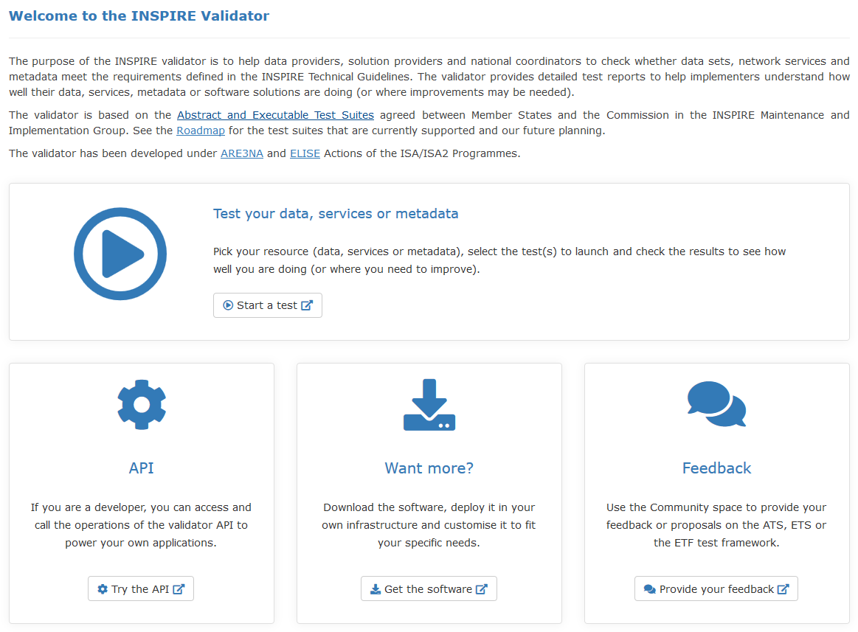

To further clarify the difference between the reference validator and the checks executed during harvesting by the INSPIRE geoportal[5], the has been renamed to "INSPIRE Geoportal Harvesting Checker", and the following disclaimer has been included on the landing page:

*This application may be used by INSPIRE data and service providers to emulate the checks executed by the INSPIRE geoportal during its harvesting process. It will report potential issues that are identified during harvesting, when the geoportal is extracting and enriching the information found in the resource in order to present them in a useful and usable fashion. It can therefore help data and service providers to improve the way their implementations are made available in the INSPIRE geoportal.*

*This application can also be used via a Web Service (instructions available* [*here*](http://inspire-geoportal.ec.europa.eu/validator2/html/usingaswebservice.html)*).*

The discussion and resolution of helpdesk issues in the 2017.4 sub-group has led to some proposals to update TG documents. The change proposals are tracked in a dedicated issue tracker[6] for scrutiny by the MIG-T. Since no comments have been received, new corrigenda versions of the TGs will be prepared and published before the end of 2018.

For the maintenance and development work on the ETF software, a governance structure has been set up, involving the two current main sponsors *interactive instruments* and *JRC*, as well as the active developers. The ToR for the Steering Group and Technical Committee are available on GitHub[7]. ETF Improvement proposals (EIPs) are collected, discussed and prioritised on Github[8], e.g. on performance improvements, UI simplification. ETF developments are now also funded through a contract with German mapping agencies (AdV).

It has been proposed to organise a workshop with national implementers to collect feedback and suggestions for improvements of the ETF software, similar to the workshops organised for the Re3gistry software and the planned geoportal workshop.

# Spatial Data on the Web

Ad-hoc actions SDW-1 and SDW-2 are discussed in background document DOC7.

## SDW-3: Web Feature Service v3.0 (WFS3)

WFS3 is the new revision of the OGC's Web Feature Service standard for querying geospatial information on the web. It is a complete rewrite of previous versions, focusing on a simple RESTful core specified as reusable OpenAPI components with responses in JSON and HTML. The first release of the standard is available at [OGC Web Feature Service 3.0 - Part 1: Core, First Draft Release](https://cdn.rawgit.com/opengeospatial/WFS_FES/3.0.0-draft.1/docs/17-069.html). The WFS 3.0 specification is currently under active development and review. Comments and change proposals can still be submitted until the end of 2018. A dedicated page in the MIG collaboration space provides [more information about WFS3](https://webgate.ec.europa.eu/fpfis/wikis/display/InspireMIG/SDW-3:+WFS+3.0).

It was agreed in the MIG-T meeting in Paris to nominate Jari Reini (FI) as the official MIG-T representative / liaison with the WFS3 drafting team, with the task to provide the consolidated input and feedback of the INSPIRE community.

A discussion paper analysing how the legal requirements for the implementation of INSPIRE download services can be mapped to the WFS3 standard was presented and discussed at the MIG-T meeting in Paris[9]. Overall, the mapping seems feasible, except for two possible major issues (to be further investigated): the link to metadata of a data set and the supported filtering capabilities. The mapping paper will be updated based on the discussion and feedback from the meeting.

During the discussion on language parameters, it was suggested that these are a more general issue and that a change to the implementing rules should be considered for these parameters.

In addition, it was agreed at the MIG-T meeting to develop example WFS3 implementations for an INSPIRE data set (FI, FR, with possible support by IT) and to submit an issue to the WFS3 drafting team on how to include links to data set metadata.

## SDW-4: Improved discoverability of INSPIRE data through mainstream search engines

During the INSPIRE Conference, an ad-hoc workshop on **Google Dataset Search**[10]featured a panel discussion on whether Google Dataset Search could be a game changer for (geospatial / open) government data and catalogs, whether search engines should also index data (and not just data sets) and how to set up a testbed to experiment and discuss indexing of data sets by search engines.The workshop sparked great interest, even though it was not included in the official programme, with more than 50 participants. Detailed notes from the workshop are available on the MIG wiki[11].

At the meeting in Paris, the MIG-T agreed that the main use case for this activity is to bring more and other users to portals/catalogues and that the activity should result in the development of a good practice document.

At the same time, the break-out group discussions showed that only few MIG-T members are familiar with the topic of search engine optimisation (SEO) for data sets and the underlying standards or technologies. Therefore, rather than further discussing the topic inside the MIG-T, it might better to organise a workshop with technical SEO/catalogue experts. Such a workshop should

* collect existing examples, good practices and information about tool support,
* discuss experiences and good practices for landing pages of data sets and how these could be generated from catalogue metadata (rather than maintaining the information in different systems)
* discuss whether/how to organise a testbed in the EU and/or national geoportals to study the effects of data set (and possibly object) annotations (by measuring the search engine results before and after),
* collect feedback and suggestions to search engines for improving data set search, and
* collect and discuss possible other uses of data set and object annotations.

To collect input for the workshop and follow-up discussions, a collaboration space (wiki) should be set up.

## SDW-5: Linking geospatial data and persistent identifiers

An initial collection of existing practices in Member States and projects on linking geospatial data and managing persistent identifiers has been carried out and was presented at the MIG-T meeting in Paris. It was agreed to document these on the MIG-T wiki, with the ultimate aim to develop a good practices paper on the topic.

# Central INSPIRE infrastructure components

## Operation, maintenance and evolution of the INSPIRE geoportal

The new Geoportal[12] was officially launched on 17 September 2018 during the INSPIRE Conference 2018. The Geoportal currently provides to users access to INSPIRE MS data sets via two main applications: **Priority Data set Viewer** and **INSPIRE Thematic Viewer**. To support the communication of the launch event a dedicated news item was published[13]. The general feedback received from INSPIRE community as well as from others (EC policy officers) was very positive.

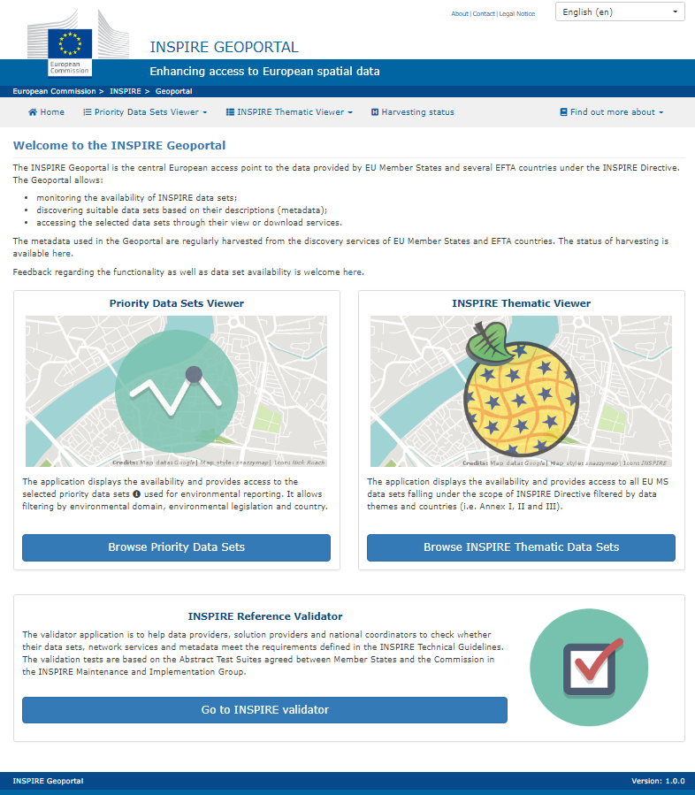

*Fig1: New Geoportal landing page*

Statistics of the visits from 17/09 until 13/11/2018

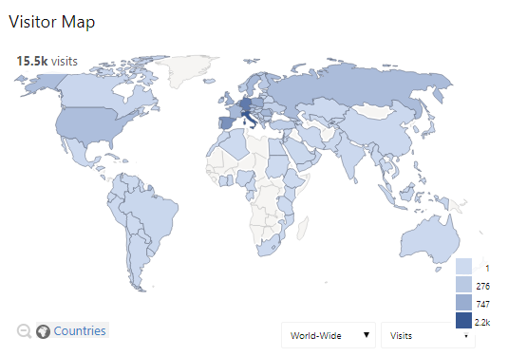

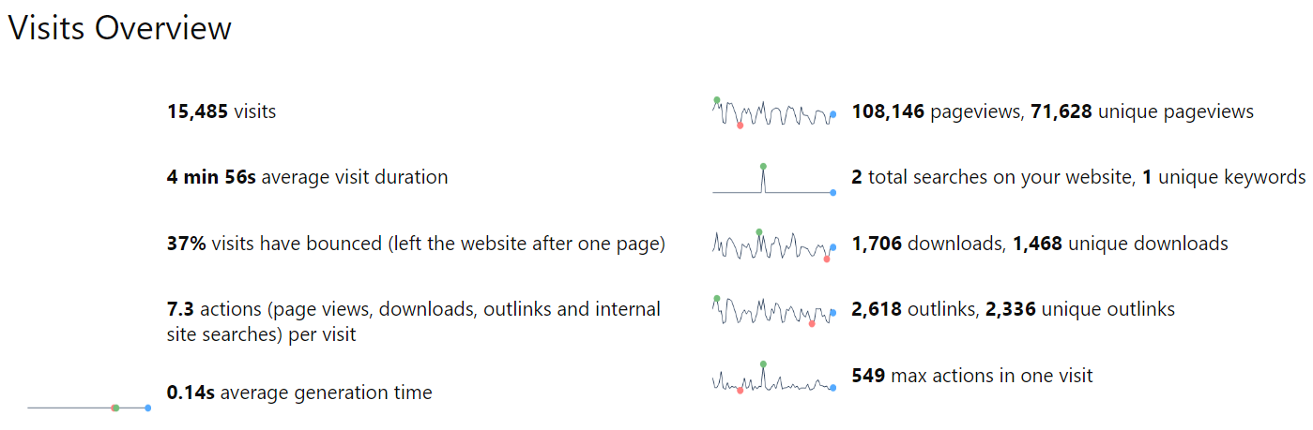

Since the Geoportal launch, further work has started on the following aspects:

1. Upgrade of the Harvesting process and changing the harvesting method from pull to push i.e. allowing MS to start the harvesting of their MD catalogues whenever required. The change will also include the new MS confirmation step before the harvested MD gets published in the EU Geoportal. The first draft version is planned to be ready for restricted testing by MS before the end of the year.
2. Daily Geoportal maintenance, Geoportal Helpdesk – due to resource limitations, the Geoportal Helpdesk support to MS has been lowered.
3. Organisation of a **dedicated technical workshop on improving the availability of your data sets** via the INSPIRE Geoportal. The main objectives of the workshop are:
   * Assessing and resolving together concrete technical issues with providing your data resources via INSPIRE Geoportal (Helpdesk)
   * Collecting and discussing proposed changes and improvements of the Geoportal (functional, organisational)
   * Setting up a network of technical experts and agreeing on the operational aspects/follow up (Harvesting, Helpdesk, ...)

The workshop will take place at JRC (Ispra, Italy) from 23-24.1.2019. Based on the official MS nominations the workshop will be attended by **all 28 EU countries and most EFTA countries**.

1. As a preparatory work for the workshop as well as based on the request from the last MIG-T meeting, a technical description of the current approach used in the Geoportal to establish links between the INSPIRE resources (metadata, data sets, network services) was prepared and will be shared with MIG, MIG-T as well as with the participants to the technical workshop.
2. The new INSPIRE analytics platform – the concept and initial work has started on the new Geoportal application and API allowing users to select and combine any possible filters to extract the required INSPIRE resources (metadata, data sets, network services).
3. Together with DG ENV the preparation of the ToR for the new Geoportal Advisory Group has started with the intention to set it up by the end of the year.

## Operation, maintenance and evolution of the INSPIRE registry & the INSPIRE register federation

A workshop on the Re3gistry software and INSPIRE register federation[14] took place on 5-6 September, which aimed at collecting and prioritising requirements for Re3gistry software and register federation and setting up a governance structure for future maintenance.

Participants submitted improvement proposals for the Re3gistry before the meeting. During the meeting, every participant was asked to rank his/her 5 top proposals out of the overall possibilities. The most voted proposals were:

* Provide support for linked data (16 votes)
* Improve filtering/search functionality in the user interface (13 votes)
* Improve the search engine to enable searching remote INSPIRE central registers from a “local” registry (9 votes)
* Enable a search history function to navigate across the item changes (9 votes)
* Provide support for additional formats to enhance interoperability, e.g. compliant SKOS/XML (8 votes)
* Provide a syndication service to notify changes in contents and/or functionalities (8 votes)
* Provide additional visualization modes, e.g. a hierarchical tree view (collapsible menus) for hierarchical registers, and an alphabetical index (glossary); suitable/suggested tools are WebVOWL and owlviz (8 votes)
* Provide a REST API for machine-readable access, filter & read actions (7 votes)
* Provide image field type support (7 votes)
* Store developed register types as templates in order to use them to create new registers (7 votes)
* Implement a web based import tool, allowing a preview of the content (for each new entry/change, create a dump of the current content) (7 votes)

The submitted improvement proposals will be documented on Github, together with an estimation of the resources that those would imply.

On the INSPIRE register federation, it was decided not to publish the Register of Registers (RoR) application officially for the time being, since not many countries are sharing or planning to share their code lists in it yet. Testing and experiments will continue in the current sandbox[15]. JRC will investigate how to integrate the RoR within the INSPIRE registry (e.g. showing in INSPIRE empty code lists types a link to the available values coming from other sources)

The workshop also discussed setting up a community around the Re3gistry. It was decided

* not to set up a steering group for the time being, but
* to create a mailing list for stakeholders and general announcements, and
* to set up the Github space[16] for collecting requirements, feature proposal and sharing roadmaps for next releases,
* organise web-conferences (e.g. to present the new versions, features, etc.) on request / when needed, and/or at physical events such as the INSPIRE Conference, FOSS4G, ISA2, etc.

1. <https://webgate.ec.europa.eu/fpfis/wikis/x/aAKOE>
2. <https://github.com/INSPIRE-MIF/2017.2/issues>
3. <https://github.com/inspire-eu-validation/community/wiki>
4. <http://inspire-sandbox.jrc.ec.europa.eu/validator/>
5. <http://inspire-geoportal.ec.europa.eu/validator2/>
6. <https://ies-svn.jrc.ec.europa.eu/projects/mig/issues?query_id=30>
7. <https://github.com/etf-validator/docs/tree/master/TOR>
8. <https://github.com/orgs/etf-validator/projects/2>
9. DOC-5 available at <https://webgate.ec.europa.eu/fpfis/wikis/x/IZvdEQ>
10. [https://toolbox.google.com/datasetsearch](https://connected.cnect.cec.eu.int/external-link.jspa?url=https%3A%2F%2Fremi.webmail.ec.europa.eu%2Fowa%2Fredir.aspx%3FC%3DJQlYcBEnsXzDoSpiqJuZcaTQM_5WWmSCmMcxHtLLvtDf1EPvhCjWCA..%26URL%3Dhttps%253a%252f%252ftoolbox.google.com%252fdatasetsearch)
11. <https://webgate.ec.europa.eu/fpfis/wikis/x/FyysEQ>
12. <http://inspire-geoportal.ec.europa.eu/>
13. <https://ec.europa.eu/jrc/en/scientific-tool/inspire-geoportal>
14. <https://webgate.ec.europa.eu/fpfis/wikis/x/-MGEEQ>
15. <http://inspire-regadmin.jrc.ec.europa.eu/ror>
16. <https://github.com/ec-jrc/re3gistry>